<https://experienceleague.adobe.com/docs/experience-manager-learn/sites/page-authoring/aem-sites-authoring-overview.html?lang=en#page-authoring>

<http://www.aeminterviewquestions.com/>

<http://www.aemcq5tutorials.com/interview-questions/adobe-aem-cq5-interview-questions-beginners/>

**What is Adobe marketing cloud ? Why do i need it ?**

Basically, it is a collection of 8 adobe marketing solutions, it helps customers to master digital marketing by leveraging these adobe marketing solutions.

* **Adobe Experience Manage**r- helps customer to create a seamless digital appearance, across all platforms and languages. That helps customers to build their brand globally and increase their demand.
* **Adobe Social** – helps customers to lead in their social media channels like *Facebook, Twitter, Google Plus* and enables customers to know its community sentiments.
* **Adobe Analytics** – like google analytics it also collects , analyse and divides visitors into segments that can be plotted on charts to get better understanding and insight about your visitors.
* **Adobe Target** – It uses Adobe Analytics inputs to deliver targeted or most relevant content to right visitor and right time. It understand customer preferences provides personalized experience to meet each customer need instantly and hence increases overall sale.
* **Adobe Media Optimizer** – It allows customers to provided targeted ads to the visitors and hence optimize overall money spent on ads.
* **Adobe Campaign** – It allows customers to provided multiple of targeted one to one campaign to the visitors based on their interest.
* **Adobe Primetime –**Primetime helps you to create, deliver and monetise personal video experiences.

Contents

1. Adobe Experience Manager 3

2. AEM Architecture 3

OSGI (Open Service Gateway Initiative) 3

Java Content Repository 3

Apache Sling 3

3. AEM Installation 4

4. Explain two methods to Start AEM? 5

5. AEM Author environment? 7

6. Developer Tools in AEM Author enironment? 12

7. How to install the package 14

8. Create Package in AEM 16

9. Install and configure Brackets in AEM 19

10. CRX folder structure or Repository’s Folder Structure : 25

11. Create folder structure in AEM 27

What is Component? Give examples. What is component Types: 27

12. Create Page Rendering component in AEM: 27

13. Create Template and then create Page using the same Template in AEM: 28

14. Decomposing a URL in AEM: 32

15. Apache sling script resolution: 33

16. Apache sling selector manipulation: 34

17. Restrict the use of template using allowedPaths and allowedTemplate properties: 36

18. Adding Thumbnail to page in AEM: 39

19. Create website structure in AEM: 41

20. Sightly/HTL language: 43

# 1. Adobe Experience Manager

1. **CMS Tool** (Content Management System)
2. AEM is Based on (1) **OSGI** , (2) **Apache Sling** and (3) **JCR**.
3. **OSGI** stands for (**Open Service Gateway Initiative**)
4. **JCR** stands for (**Java Content Repository**)
5. **AEM Versions** --> 6.0 (2014), 6.1 (2015), 6.2 (2016), 6.3 (2017), 6.4 (2018), 6.5 (2020)
6. Old name is **CQ5** (Communique).
7. **CQ5** was developed by *Swiss-based software company* named***Day Software*** in 2008.
8. In 2010, adombe acquired company ***Day Software*** and *renamed* ***CQ5*** *to* ***AEM***.

# 2. AEM Architecture

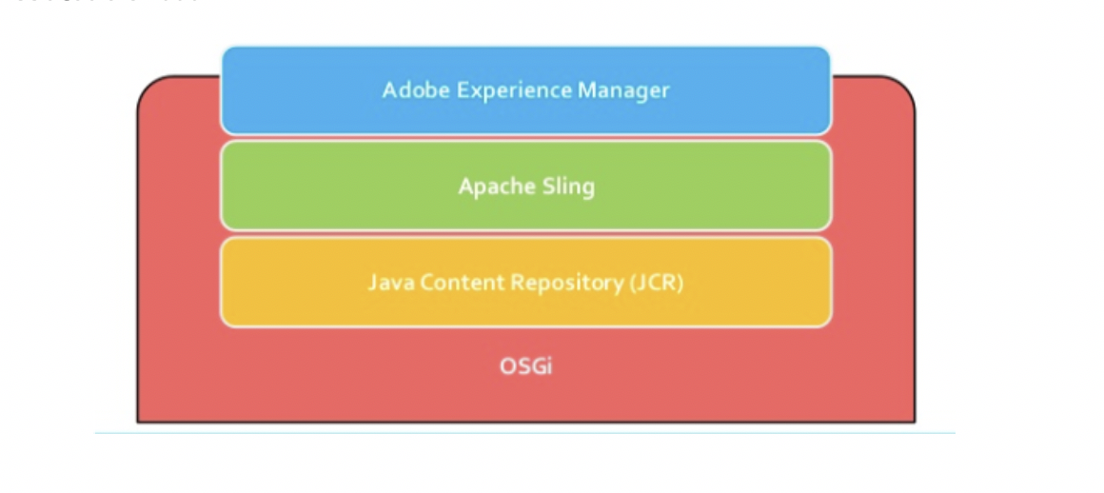

# OSGI (Open Service Gateway Initiative)

1. OSGI is a **major building block** in AEM which makes it **modular**.
2. OSGI is a **Java framework** for developing modular applications.
3. OSGI breaks the application into individual **modules** which are called **bundles**.
4. **Bundle** = **JAR** (**J**ava **AR**chive ) + **Manifest file** (metadata and its dependencies).
5. **Manifest file** is required by OSGI to **manage the visibility of classes** between bundles.
6. OSGI is **set of specifications** and it is implemented by **Apache Felix** (used by AEM).
7. To view OSGI console visit below link:

<http://localhost:4502/sytem/console>

# Java Content Repository

1. **JCR** is an **Object Database** – Supports **Structured and unstructured content**.
2. **Java API** to access **content repository**.
3. Made up of **nodes and properties**. (http://localhost:4502/**CRX/DE**)
4. **Stores** *everything*. (**All data structures**, HTML, CSS, Images, Videos, Text)
5. JCR makes use of **CRX** (*Content Repository Extreme*).
6. **URL:** [http://localhost:4502/**CRX/DE**](http://localhost:4502/crx/de) (here content files are stored for CMS website -> HTML, CSS, Images, Videos, text, etc)

# Apache Sling

1. **Web Framework** based on **REST** (**Re**presentation **S**tate **T**ransfer) principles.
2. Everything as a **resource**.
3. **URL** --> **Resource** --> **Script/Servlet**.
4. **Resource Oriented**. Each **Resource** is mapped to a **JCR node**.

***Bundle Manifest Metadata***

| **Header** | **Description** |
| --- | --- |
| Manifest-Version | Required attribute for all JAR file manifests and must be the first entry. |
| Bundle-Activator | Specifies the name of the class used to start and stop the bundle. |
| Created-By | Defines the version and the vendor of the Java implementation on which this manifest file is generated. This attribute is generated by the JAR tool. |
| Import-Package | List of the Java packages that this bundle requires. |
| Export-Package | List of the Java packages that are visible from the bundle and available for import. |
| Bundle-Version | Version of the bundle, using the format, X.X.X. |
| Bundle-Name | Descriptive, human readable name for the bundle. |
| Bundle-Description | Short description of the bundle. |
| Bundle-DocURL | URL pointing to documentation about this bundle. |
| Bundle-ManifestVersion | Specifies the version of the OSGi manifest header syntax in the header. Bundles using this version of the Framework specification (or later) must specify this header. The syntax is: Bundle-ManifestVersion ::= number. Framework version 1.3 (or later) bundle manifest version must be ’2’. Version 2 bundle manifests do not have to specify the bundle version since this version header has a default value. |
| Bundle-Vendor | Human-readable description of the bundle vendor. |
| Bundle-SymbolicName | The only required attribute for OSGi manifests. Specifies a unique name for the bundle. With Bundle-ManifestVersion it allows a bundle to be uniquely identified in the Framework. A bundle with a given symbolic name and version is treated as equal to another bundle with the same (case sensitive) symbolic name and exact version. The Bundle-Name manifest header provides a human-readable name for a bundle and is therefore not replaced by this header. |
| Implementation-Version | Specifies the minimum extension implementation version number that is required by the applet. The Java plug-in will compare the value of this attribute with the Implementation-Version attribute of the installed extension to see if a more recent implementation must be downloaded. |

# 3. AEM Installation

**Pre-requisites:**

1. AEM **start-up jar** file.
2. **License key properties** file
3. **JDK** version **1.8**
4. **4** GB - free **HD space**
5. **4** GB – **RAM**

**AEM Installation Steps:**

1. Go to following Adobe URL:

<https://solutionpartners.adobe.com/home/registration.html>

1. Register yourself with your company email Id.
2. Sign In

# 4. Explain two methods to Start AEM?

**Method 1 - Graphically:**

1. **Double click** on **JAR** file named *aem-author-4502.jar* (AEM **start-up jar** file).
2. It will open **pop up** and will take 2-3 mins to load **AEM instance**.
3. Once completed, it will *automatically* open **Author instane** (*http://localhost:4502*) in browser.
4. *To close/start* AEM instance, click on **ON/OFF** button on graphical pop up.

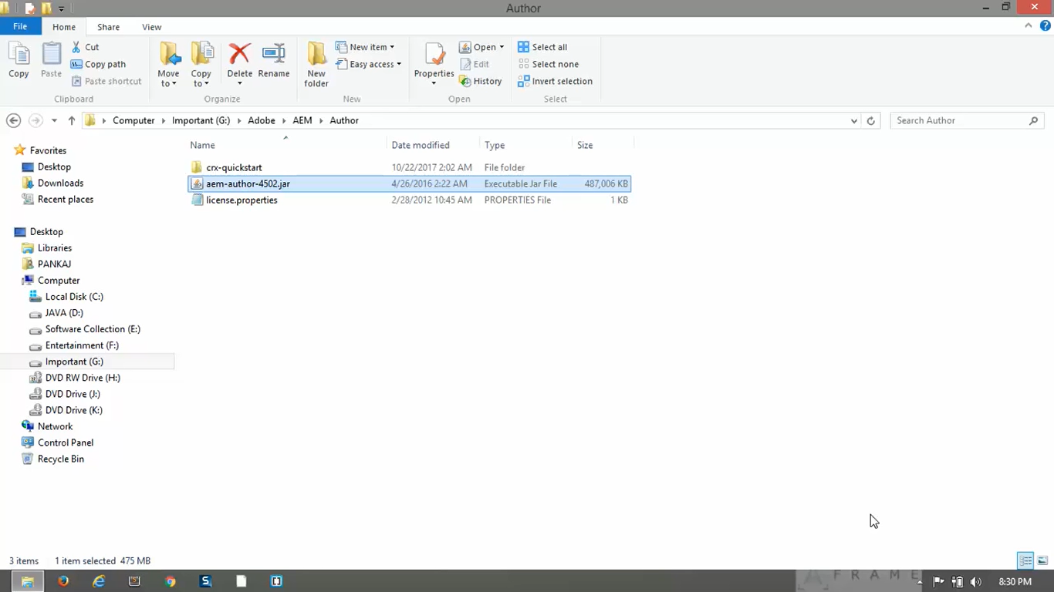

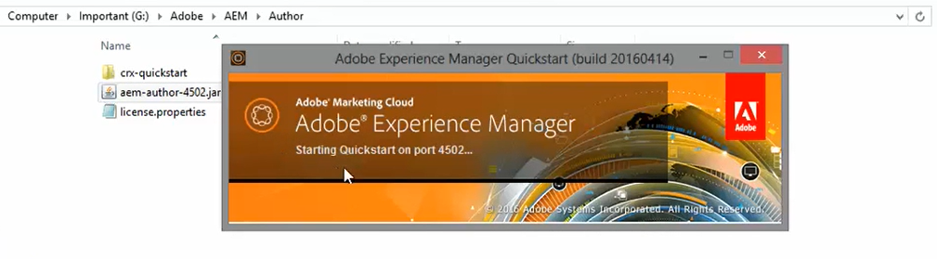

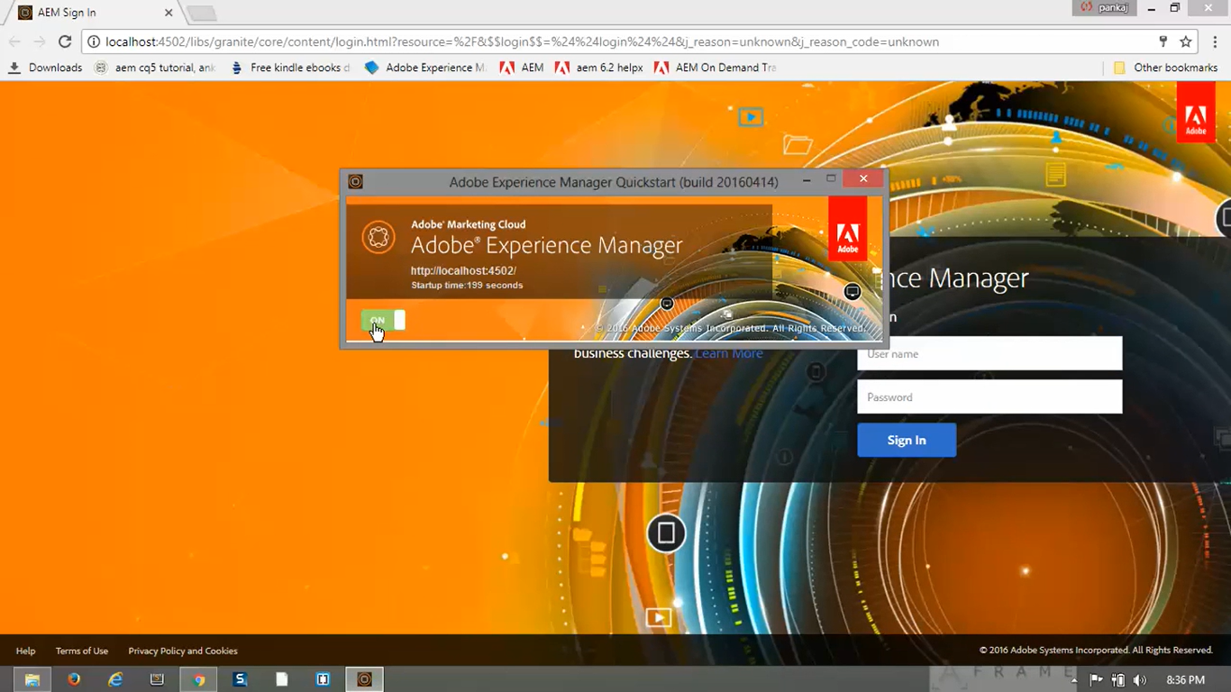

**Method 1 – Using Command prompt:**

1. Go to **command prompt**
2. Go to path **Author folder** of your **AEM instance** **installation directory** (i.e. C:\Adobe\AEM\Author).
3. Type java -xmx1024m -jar aem-author-4502.jar -gui (i.e. jar file name in the last).
4. This method is usually ***preferred*** because it provides you the way of specifying **performance tuning mechanism**, such as providing *amount of RAM* to be used by AEM instance process. That is maximum size the heap can grow up to 1MB (xmx1024m).

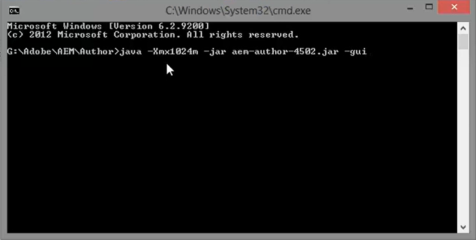

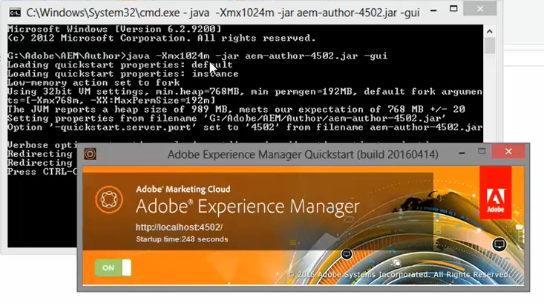

5. AEM Author environment?

**Login** into **Author environment** with **default** **username** as *admin* and **default password** as *admin.*

**Header bar** of the **Author Environment page** contains various **options** such as below.

1. **Search** items in AEM
2. **Help resource**
3. **AEM Cloud Solutions** (Adobe Analytics, Adobe Campaigns, Adobe Primetime, Adobe Social, Adobe Target)
4. **Notifications** toviewprocessworkflow messages and intimations.
5. **User Profile** toconfigure settings.

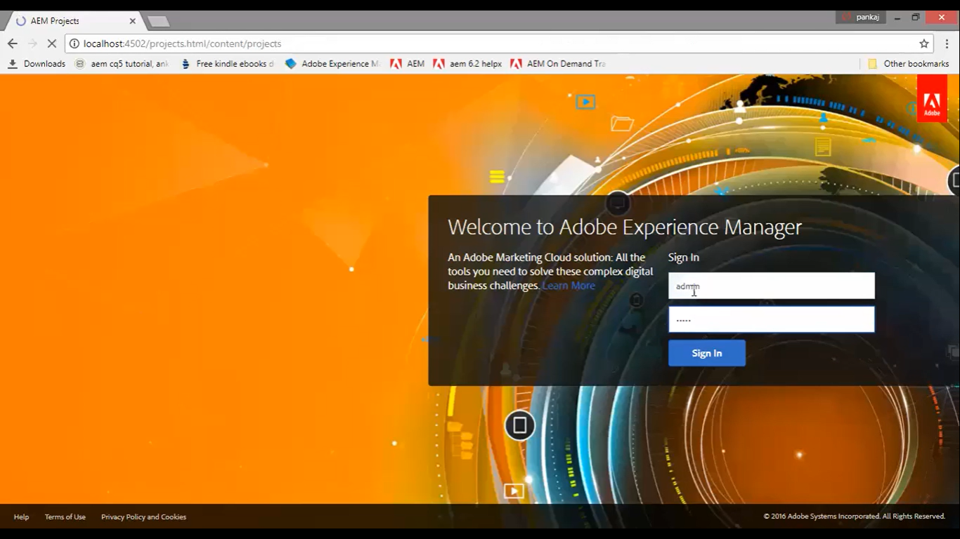

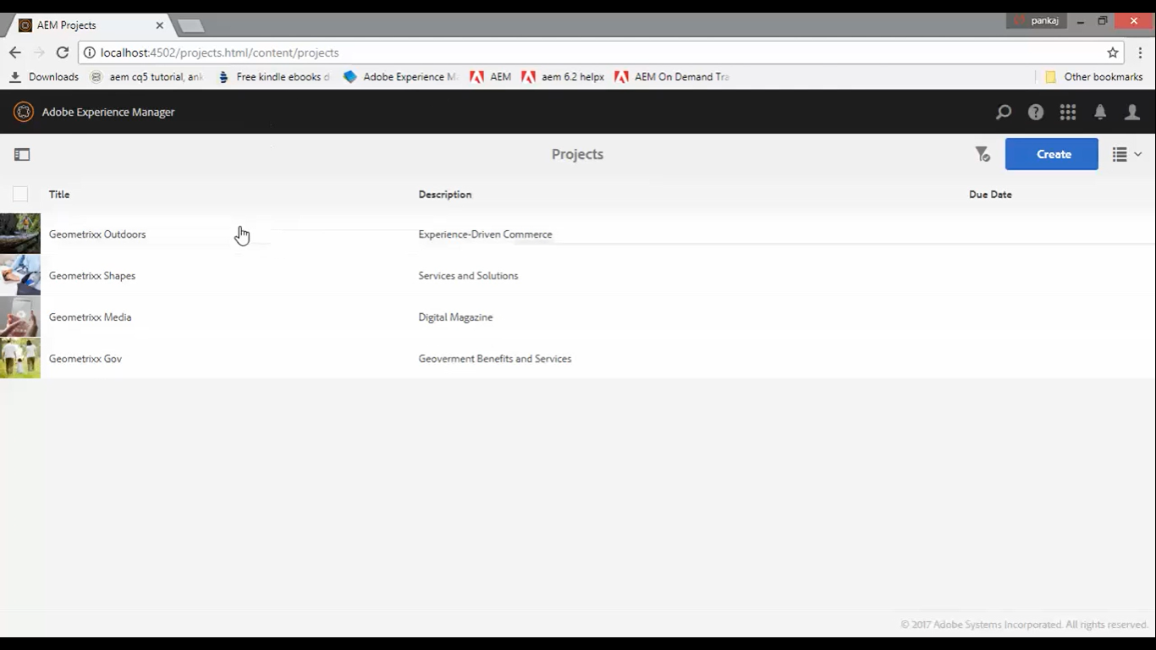

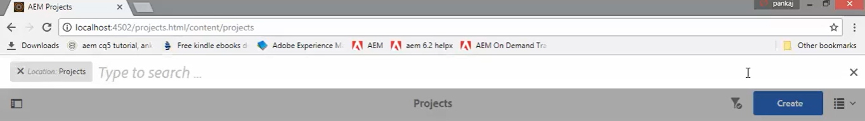

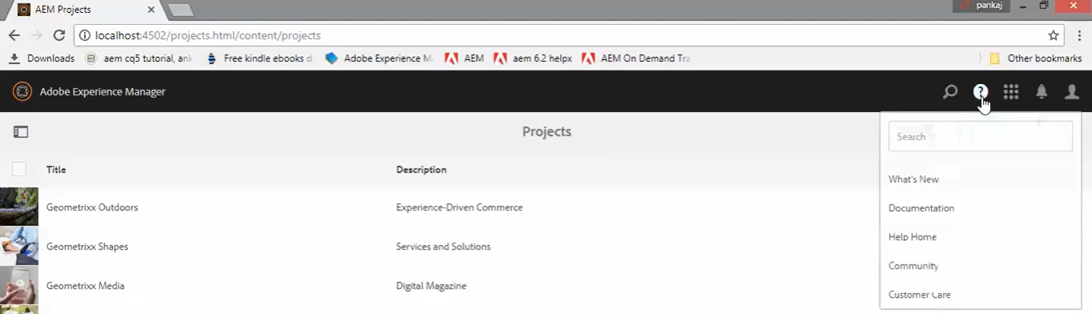

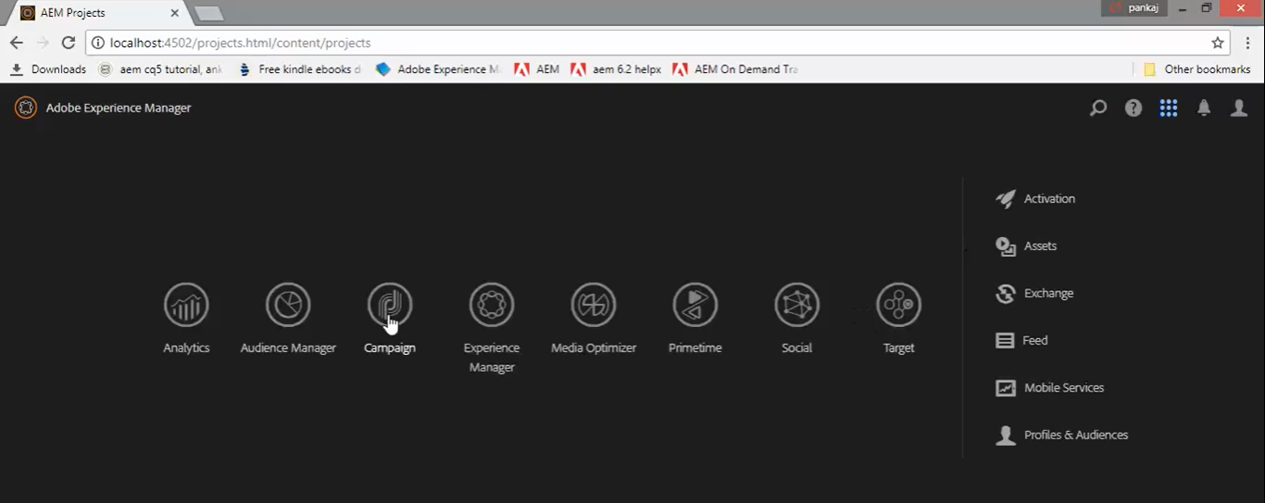

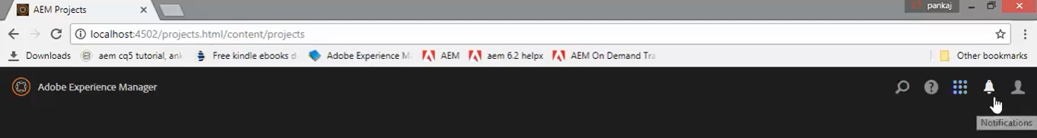

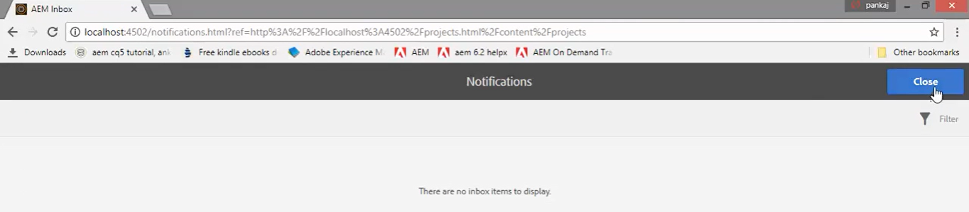

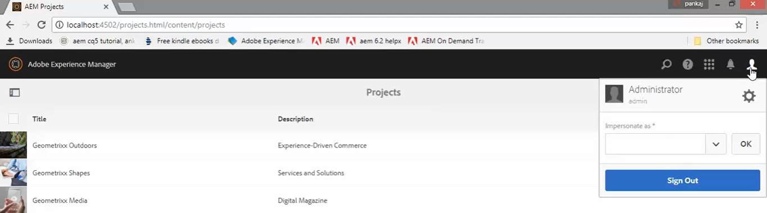

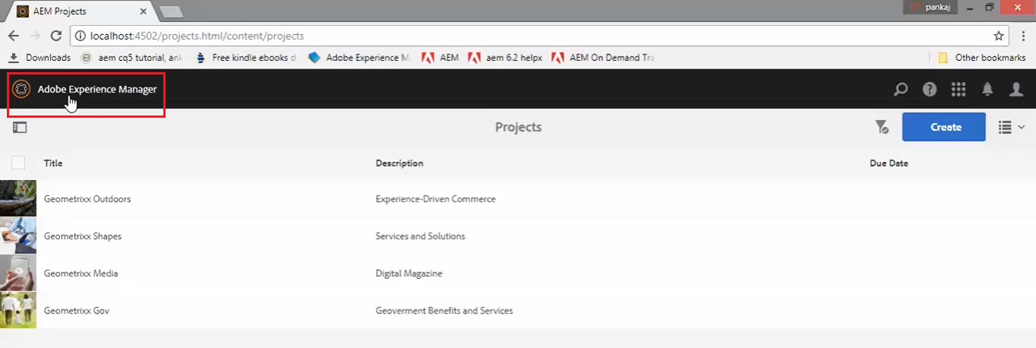

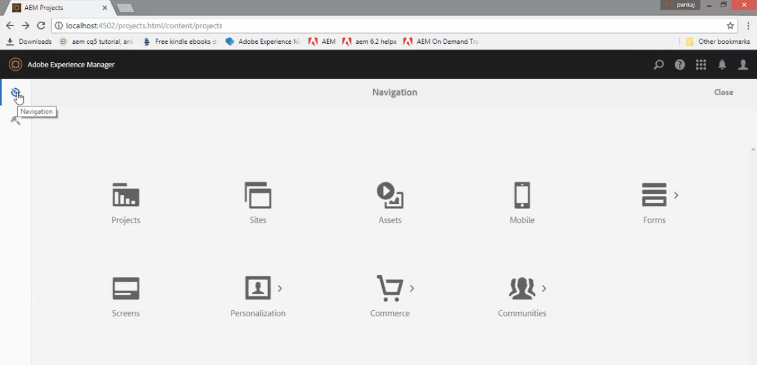

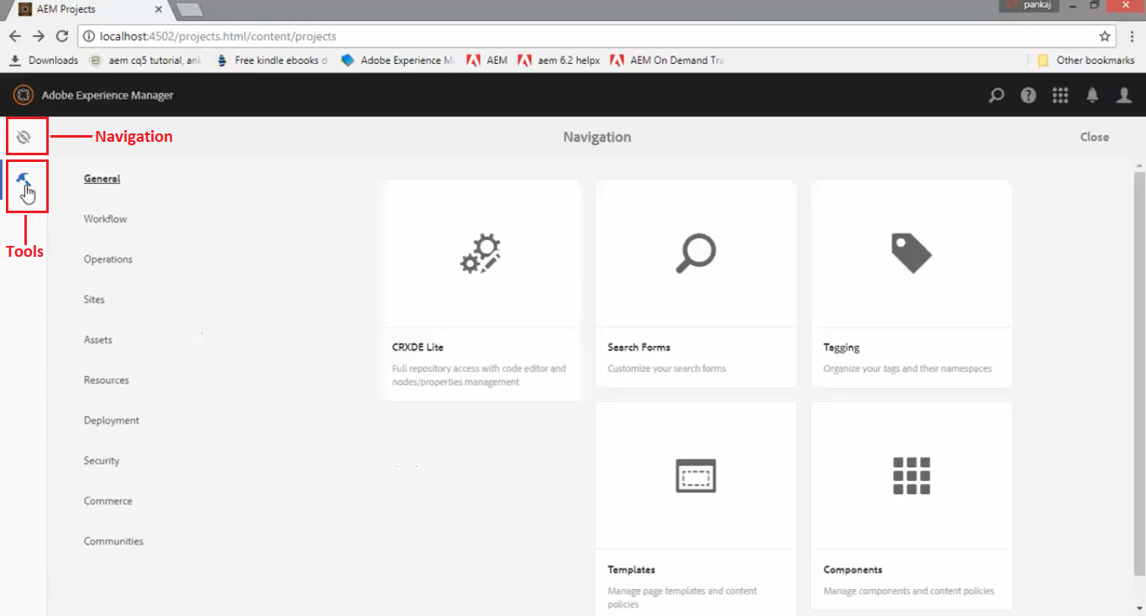

**How to create a webpage in AEM?**

Go to **Author Environment page** --> click on **AEM** **Navigation icon** present at *top left corner* -->

Click on **Sites** --> Then select a **page** from page categories and click on **Create** button.



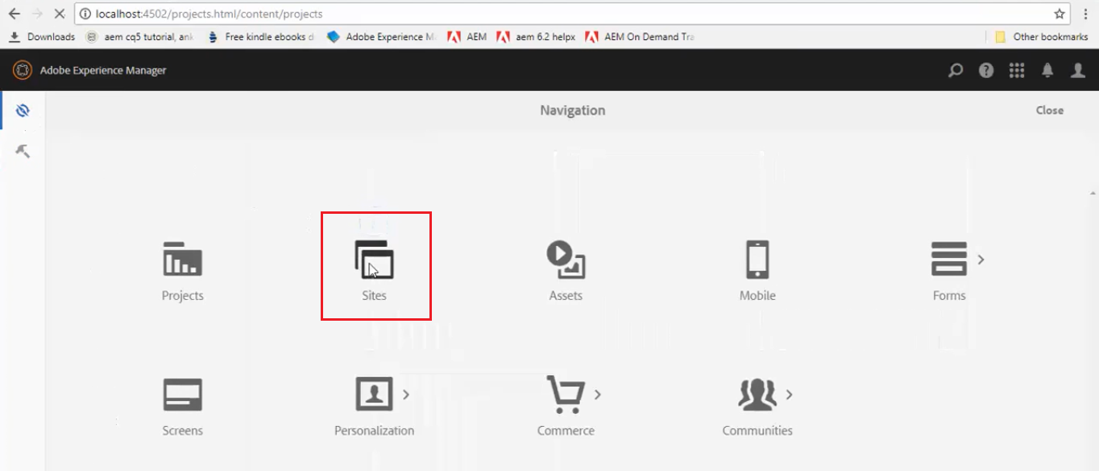

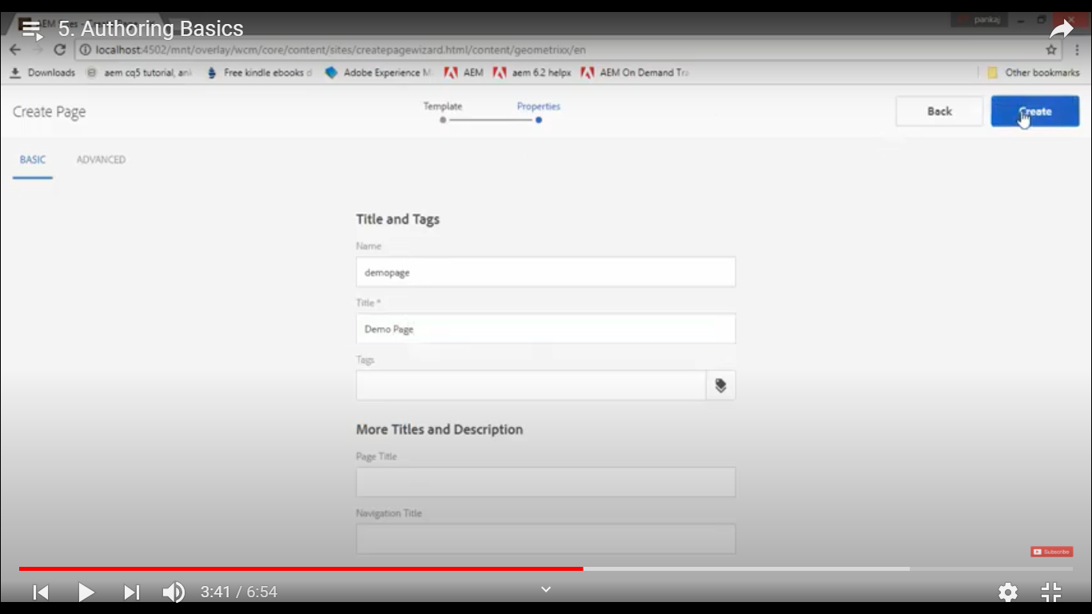



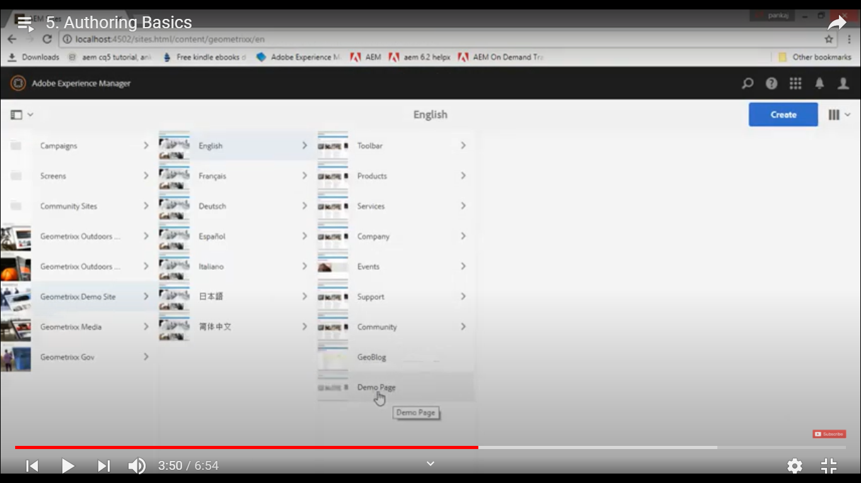

**Page** in AEM is *bunch of components*. **Component** is combination of **template** (HTML-CSS) and some **logic**. **Components examples** are *header, footer, image with title & subtitle, Video with title and subtitle,* etc.

Now once page is created, you can drag and drop components to this page. For example, add text, image, catcha, textbox, dropdown, password, and many other components to page.

6. Developer Tools in AEM Author enironment?

1. **Web Console**

Manage Bundles and Configurations.

URL: <http://localhost:4502/system/console>

**Bundles:**

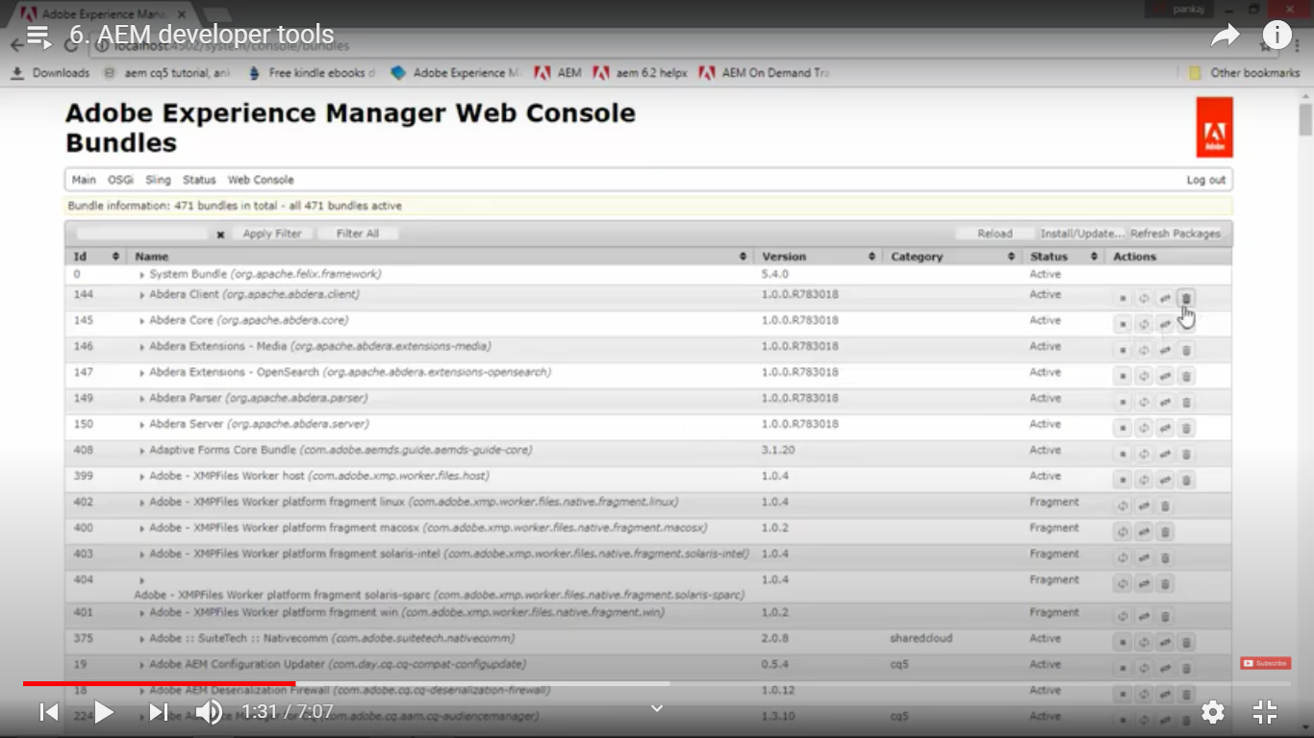

**Components:**

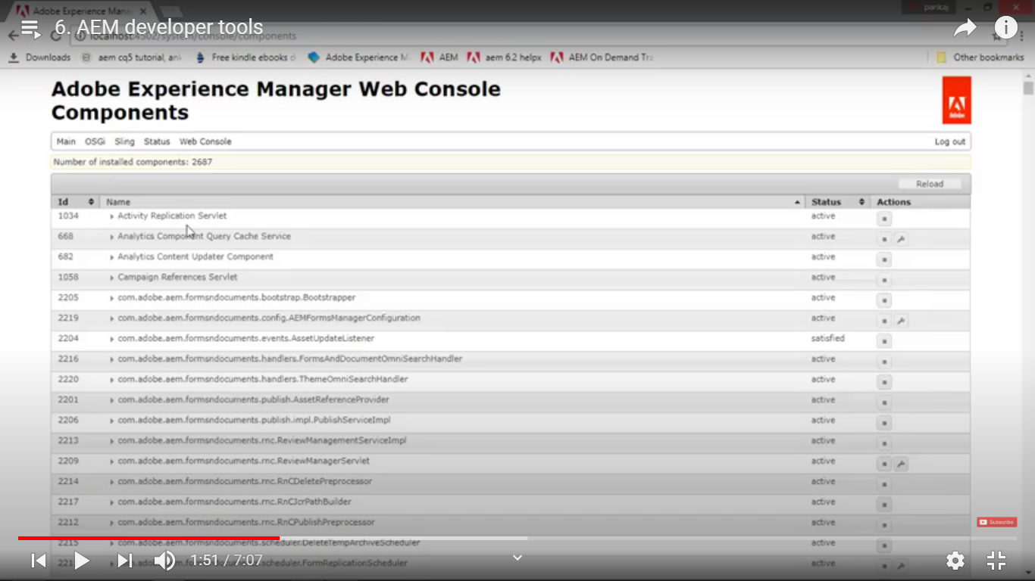

1. **CRXDE Lite**

Browser based IDE.

Tool for working with node and properties. Nodes can be folders and files (HTML, css, images, videos, etc)

URL: [http://localhost:4502/**CRX/DE**](http://localhost:4502/crx/de)

Browser based UI which is basically IDE (like Visual Studio, eclipse).

As shown in below image,

1. Explorer Pane on left side (for traversing through and selecting a specific node)
2. Editor Pane on right upper corner (for editing HTML/CSS file) and
3. Properties Pane on right bottom corner to view and edit properties.

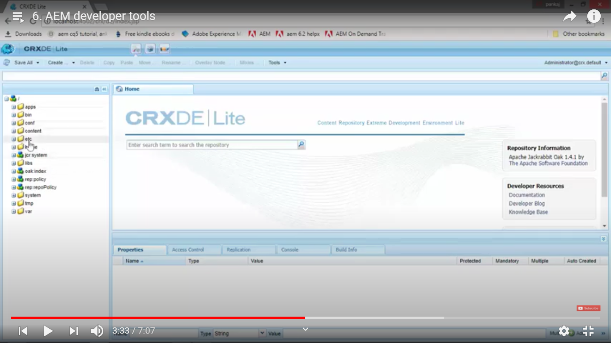

You can create, delete, cut, copy, paste and rename any node.

If you select any node, it will automatically show all its properties in Properties Pane.

If you selected a node which is file, then its content will be displayed on Editor Pane.

This editor pane does not provide features of premium IDEs such (as Visual Studio, eclipse)

Editor Pane will not contain features any intellisense, Go to Line Number, Auto Indent and other types of standard features which are provided in many popular IDEs.

1. **Packages (2 ways of handling)**

A) Package Manager

To ***Import/Export*** *Repository* Content (HTML/CSS files, images)

To **Transfer** *content* between **Author** instances to **Publish** instances or vice versa.

To ***Install*** *new functionality* which is developed in *some other project*.

To ***Backup*** *repository content*.

URL: <http://localhoost:4502/crx/packmgr>

B) Package Share

**Centralised server** that can contains both *private* and *public* packages which may include *hotfixes, packages* provided by Adobe.

One of the packages provided by Adobe is used to ***convert*** *normal dialog box* to *touch UI dialog box*.

**To use** package share, you need to have *Adobe ID* and *its credentials*.

URL: <https://www.adobeaemcloud.com/content/packageshare.html>

7. How to install the package

1. **Package** is basically *a ZIP file* which contains list of files (such as *HTML* files, *CSS* files, *Images*, etc).
2. Go to <http://localhoost:4502/crx/packmgr>
3. Click on **Upload package** button on right top corner.
4. **Select** the package ZIP file and click **OK**. (Check **Force Upload** checkbox if you want to **overwrite**)
5. That uploaded package will be shown on the same page.
6. Now click on **Install** button on that package. You will see **activity log** for the files installed.
7. Changes related to package installation will be done in content/dam/<custom-path> folder (**CRX/DE**).

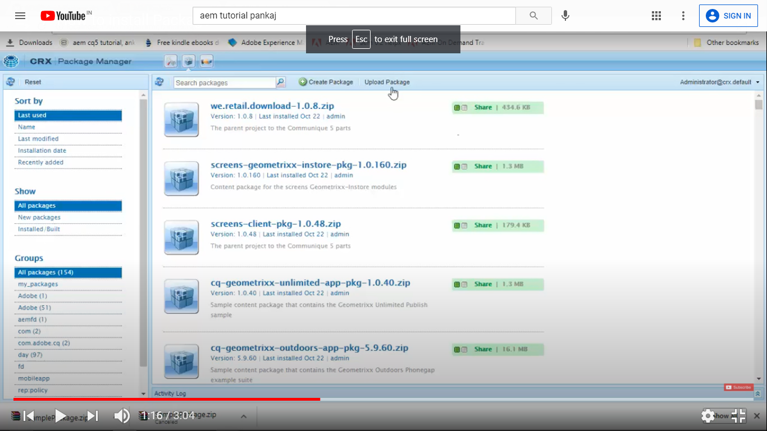

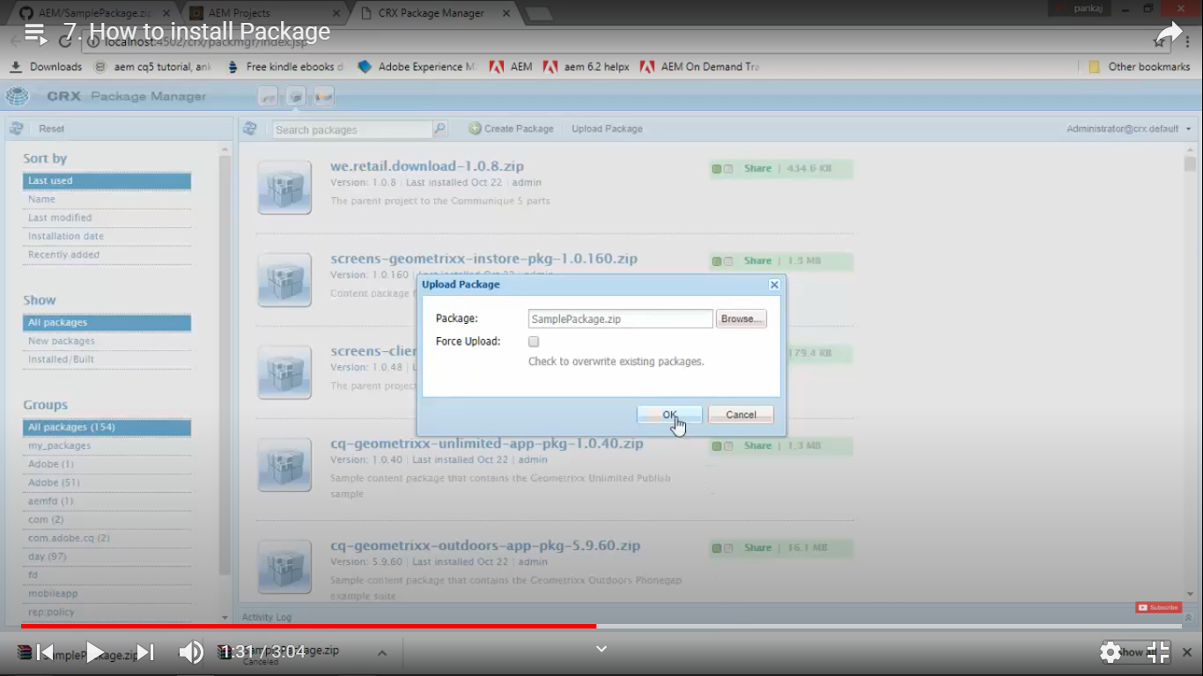

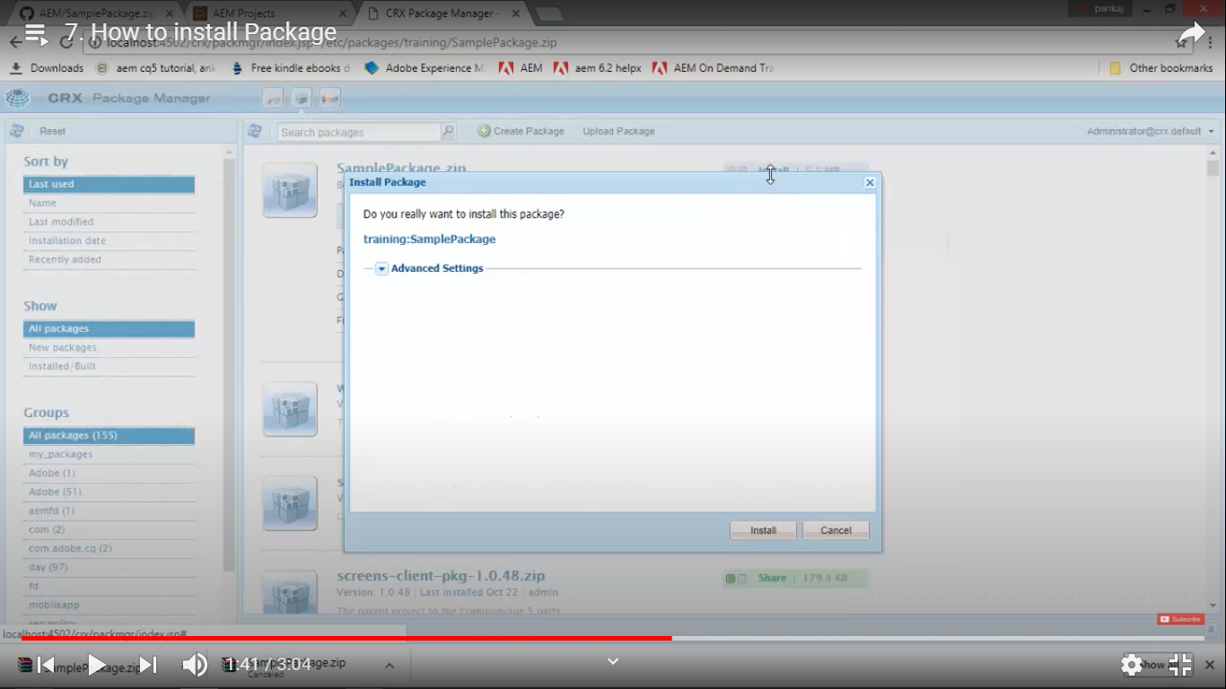

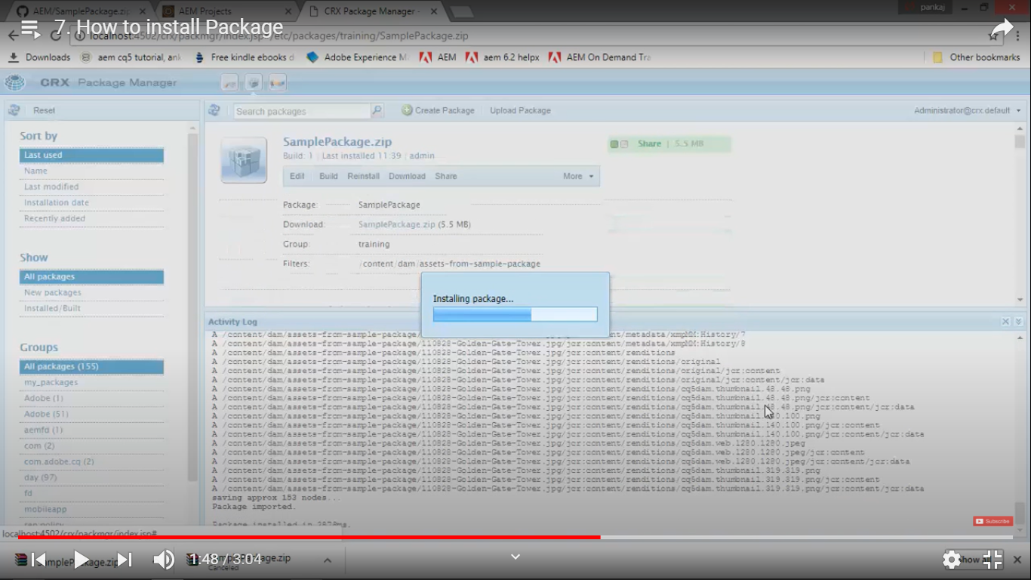

# 8. Create Package in AEM

1. Go to <http://localhoost:4502/crx/packmgr>
2. Click on **Create package** button on right top corner.
3. On **New Package** dialog box, enter values in fields **Package Name**, **Version** and **Group** --> click **OK**.
4. That *newly created package* will be *shown on the same page*.
5. On **Edit Package** dialog box, click on **Filters** tab --> **expand** nodes till you reach the path of the **component/folder** --> **Select** *component/folder* --> Click **OK** --> Click on **Done** --> Click on **Save**.
6. Click on **Build** *link* on same page. Click on **Build** button on **confirmation** dialog box.
7. This will create **<package-name>.zip** file and you can **share** it with other developers so that they can **install** on their local AEM instances and **use** the same. Or you can **install** it on *Test*, *QA* or *Prod* **environments** so that it will be accessible to all developers.
8. Similarly, *you can* **create package of your entire project** and share it with others.

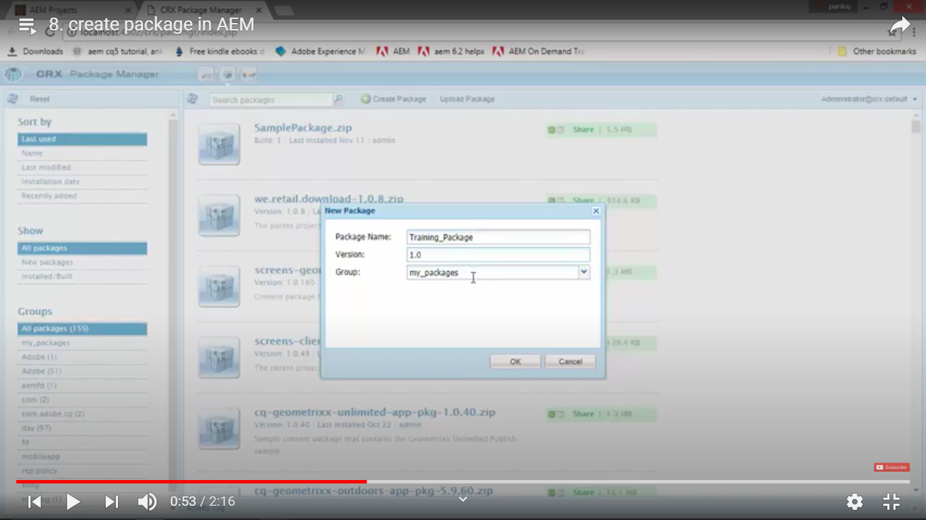

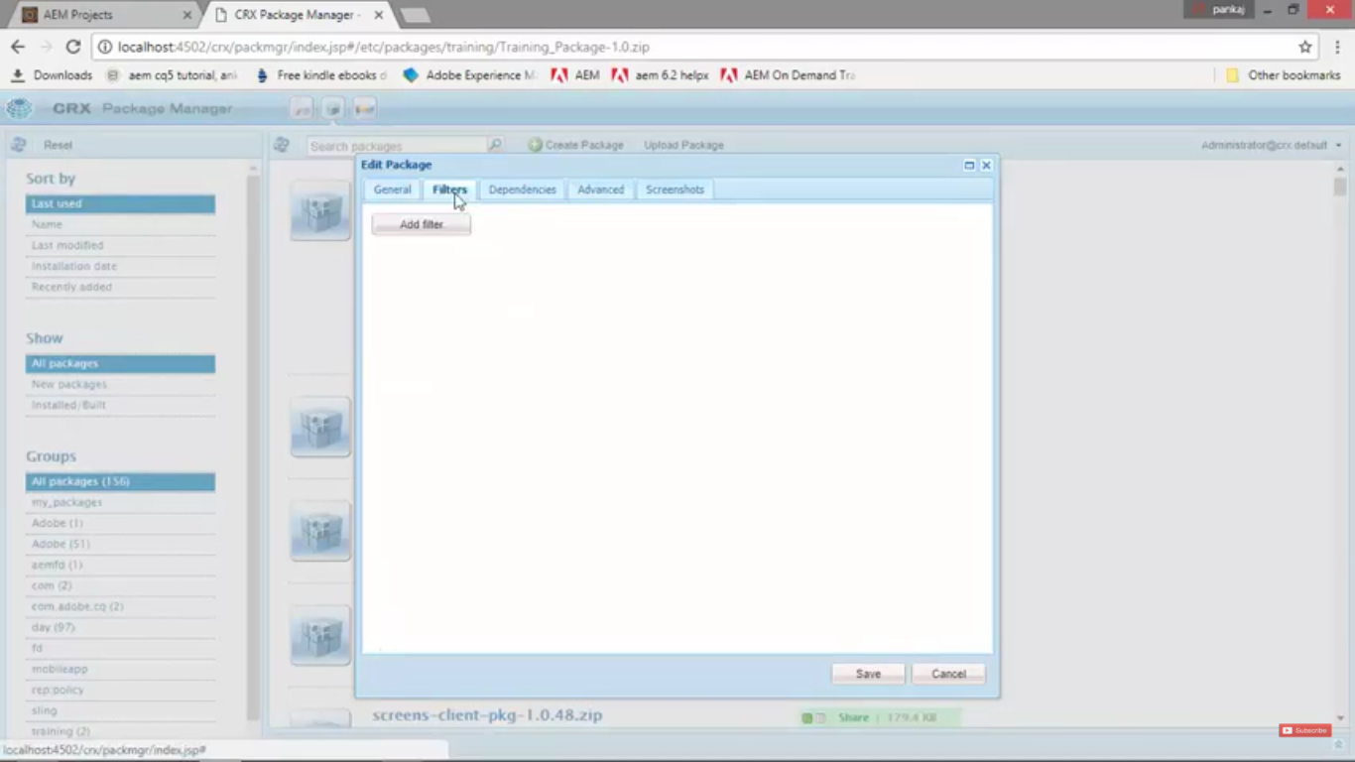

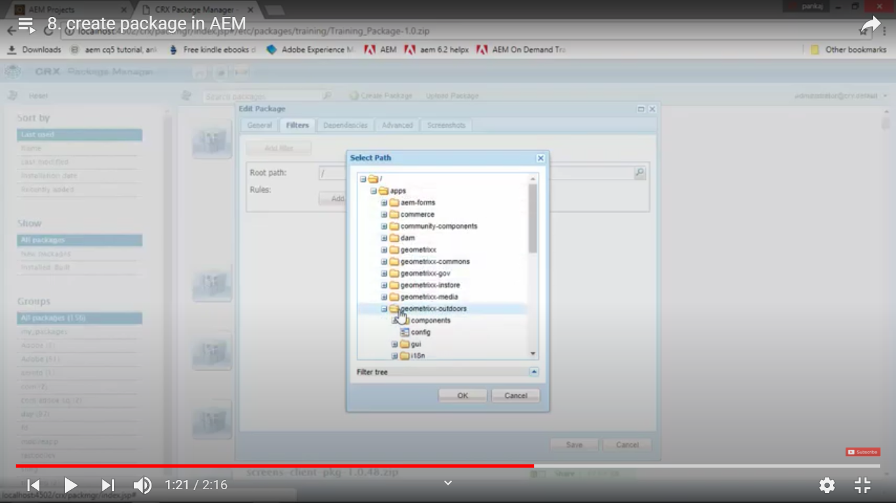

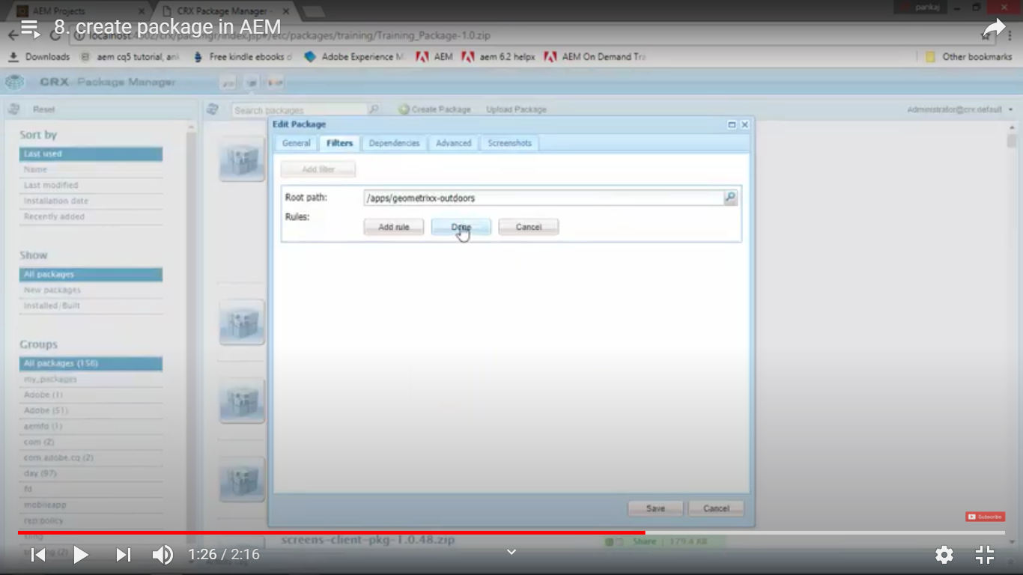

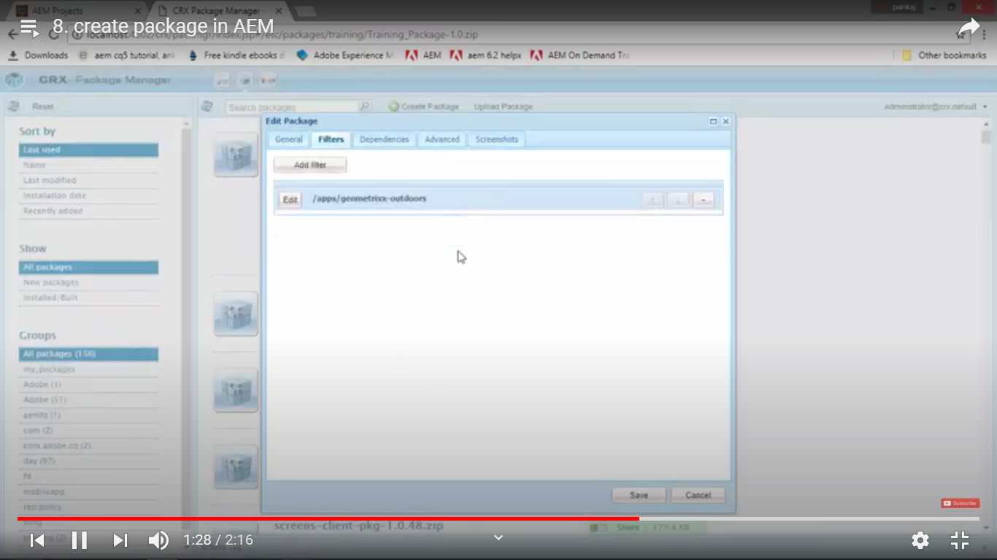

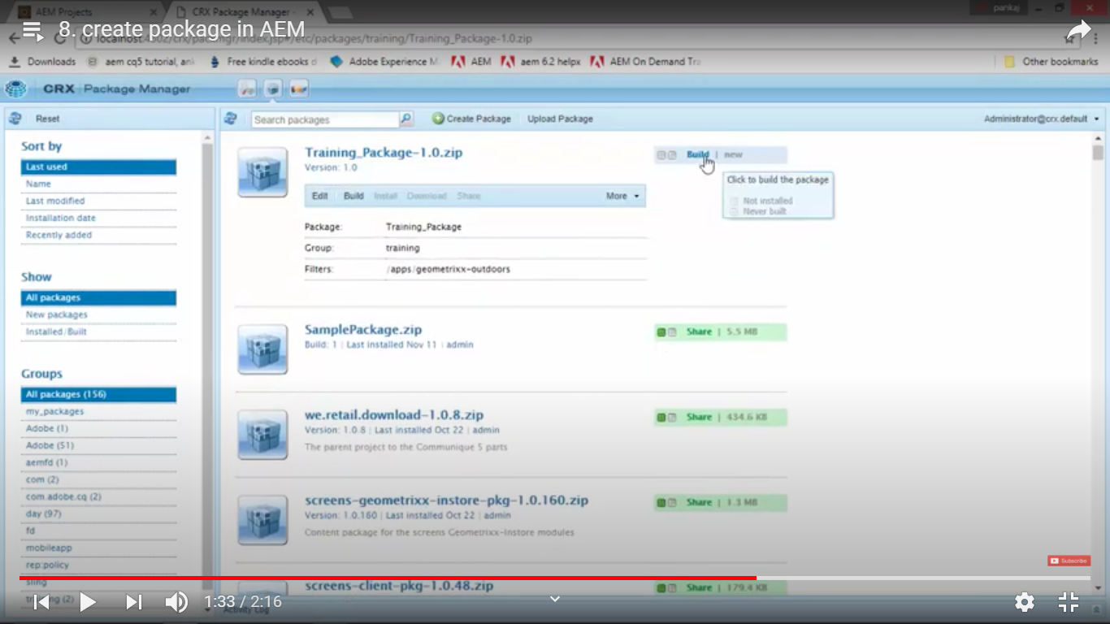

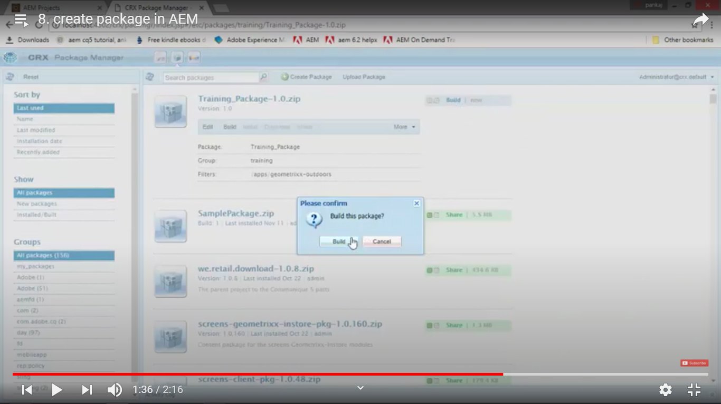

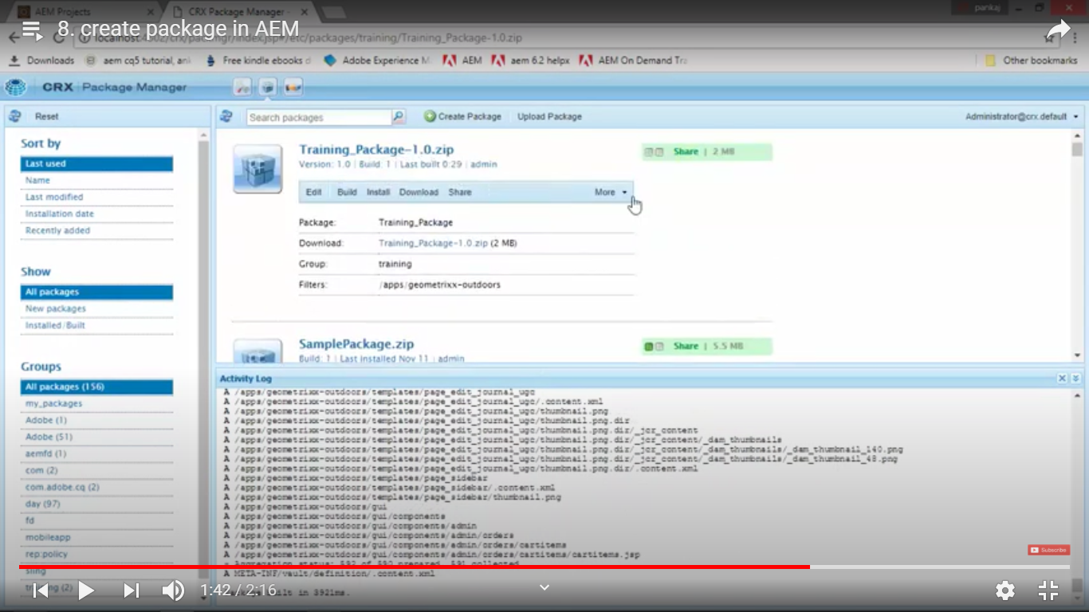

# 9. Install and configure Brackets in AEM

1. **Brackets** is developed by Adobe and ***open source code editor*** for HTML, CSS and JavaScript.
2. **Download and install** ***brackets*** application from **URL** <http://brackets.io/>.
3. **To install** - ***brackets*** for AEM, we need to **install** the ***AEM brackets plugins extension*** from AEM application which we have just installed.
4. **To install** - ***AEM brackets plugin extension***, open brackets application which is just installed.
5. Click “File” Menu, click on Extension Manager.
6. Search “AEM Brackets Extension”. Click on “Install”.
7. Restart Bracket Application again.
8. To edit files in your package using brackets application, unzip your <package-name>.zip file.
9. You will see 2 folders, “jcr_root” and “META-INF”.
10. In Brackets application, Go to “Files” menu, click on “Open Folder”, select “jcr_root” folder.
11. Contents of “jcr_root” folder will be listed on left hand side in explorer view of the Bracket application.
12. Click on “AEM” menu, click on “Project settings”.
13. In project settings dialog box, confirm following

**Server URL:** <http://localhost:4502>

**Username:** admin

**Password:** admin

1. Make sure you’re connected with your local AEM instance.
2. In Brackets, in explorer pane (on left side), go to below node and Double click on the node:

app/<project-name>/components/activities_page/body.html

1. On line 33, type below to display Title and Path of the page:

Title: $(currentPage.Title) <br />

Path: $(currentPage.Title)

1. Go to <http://localhost:4502/>, click on Sites,
2. Click on your <Project-name> --> Activities --> Bikings (your page/component)
3. Click on “Edit” from top of the page.
4. It will open your HTML page and you can see your change reflected on the page.
5. If you have edited the same file from **CRX/DE** then you can import these changes in Brackets file too. To achieve this **Right Click** on the file. Click on “Import from Server”.

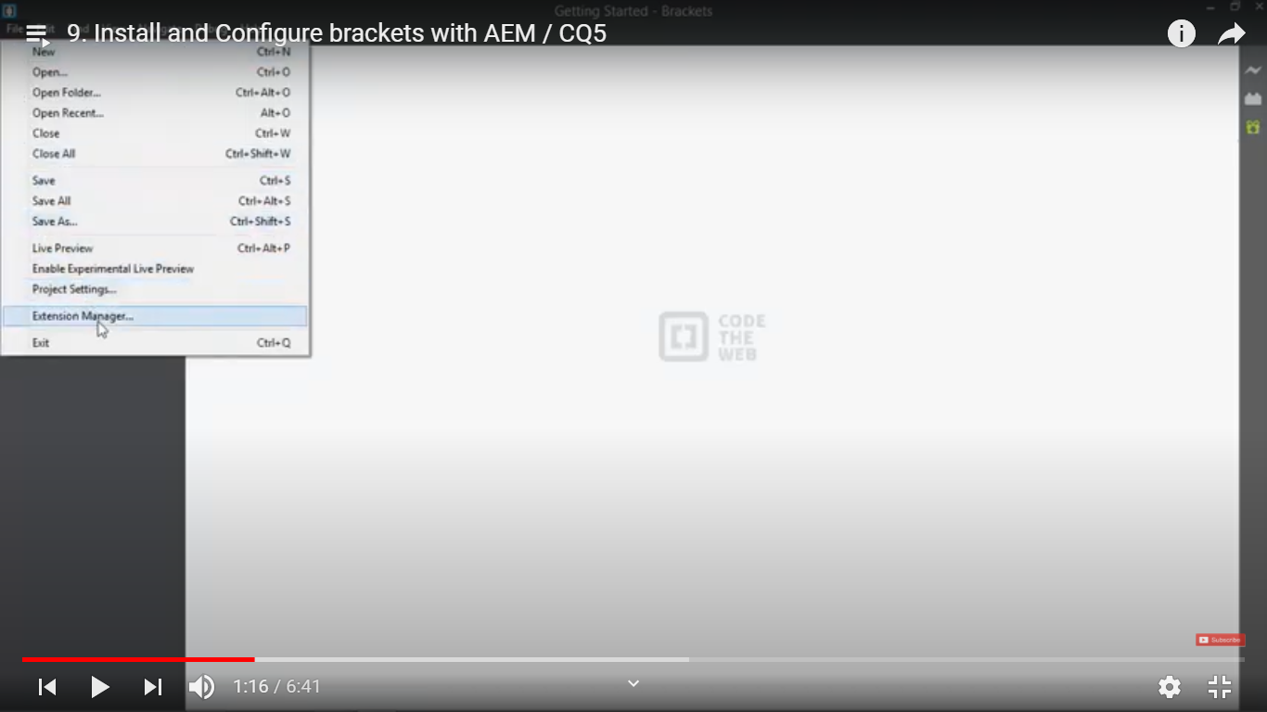

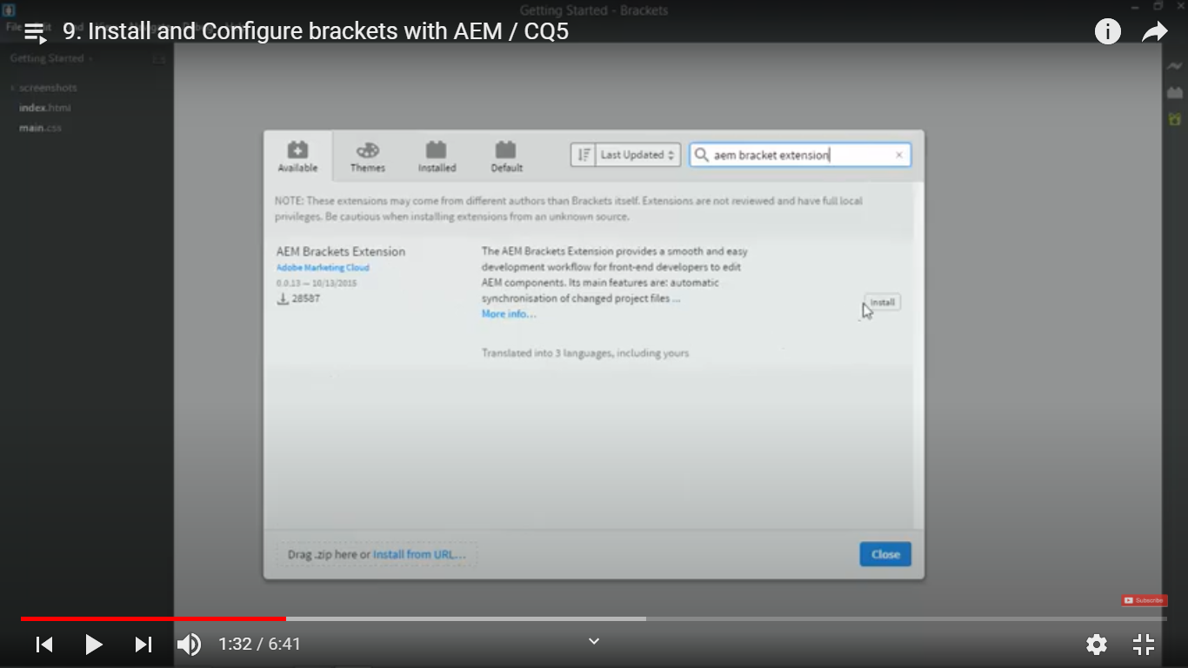

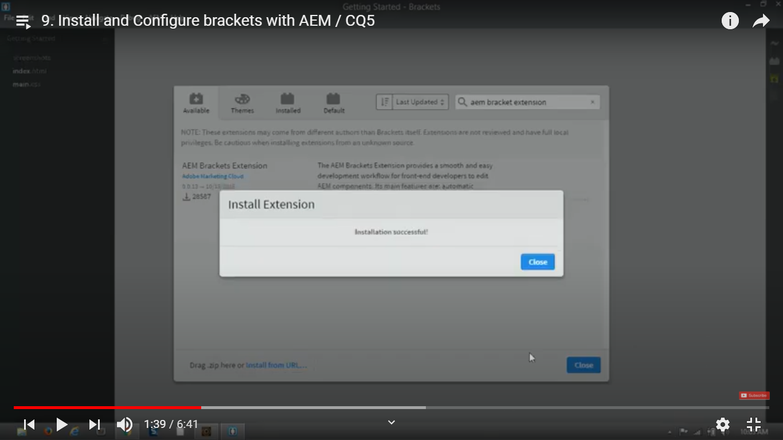

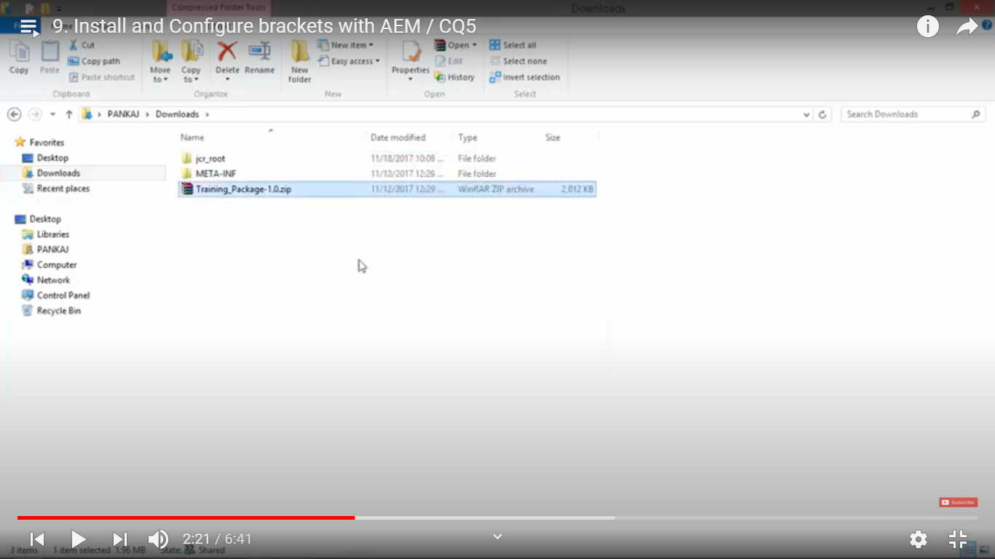

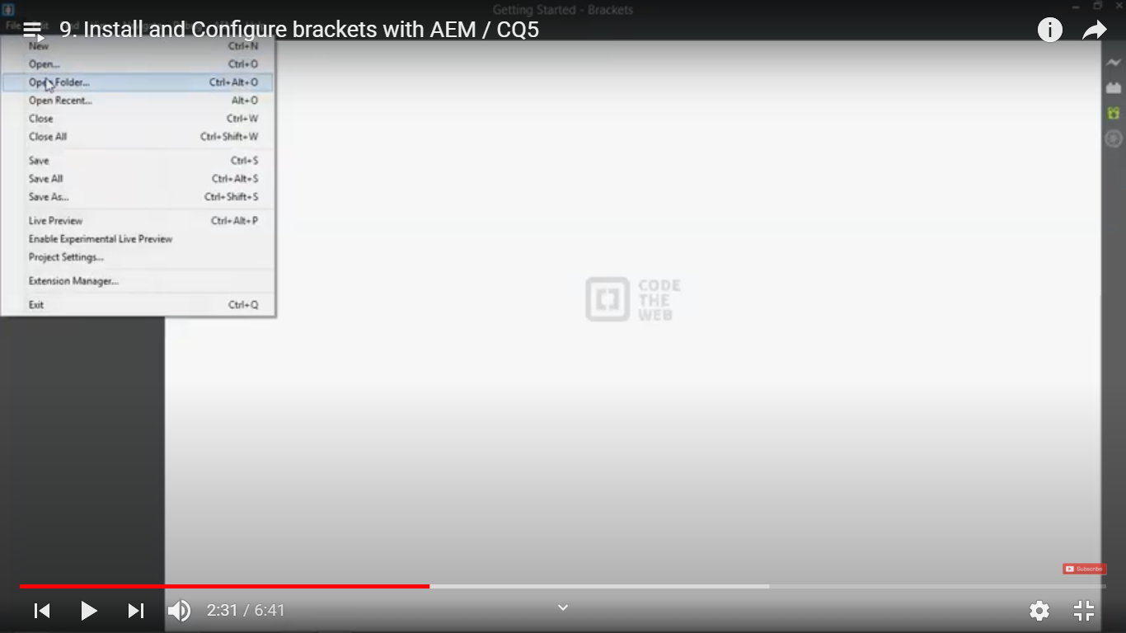

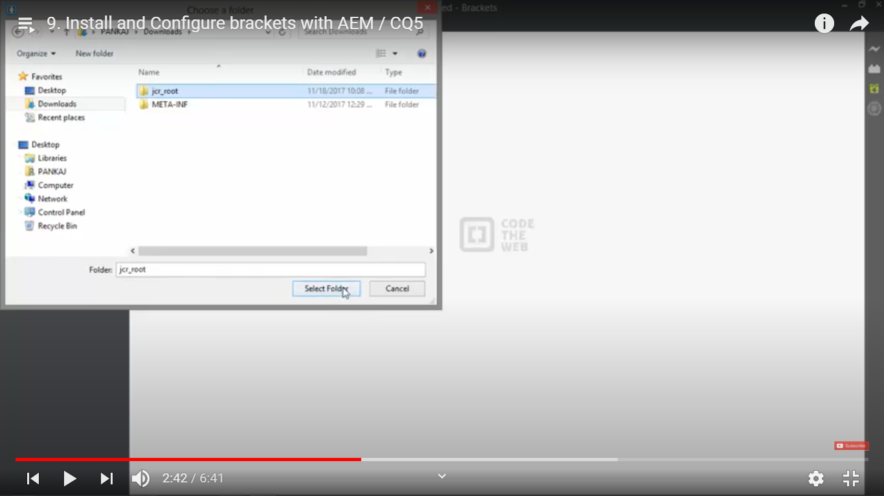

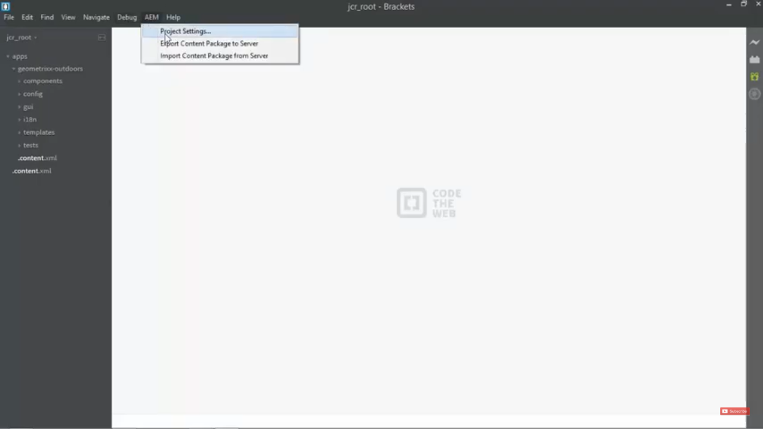

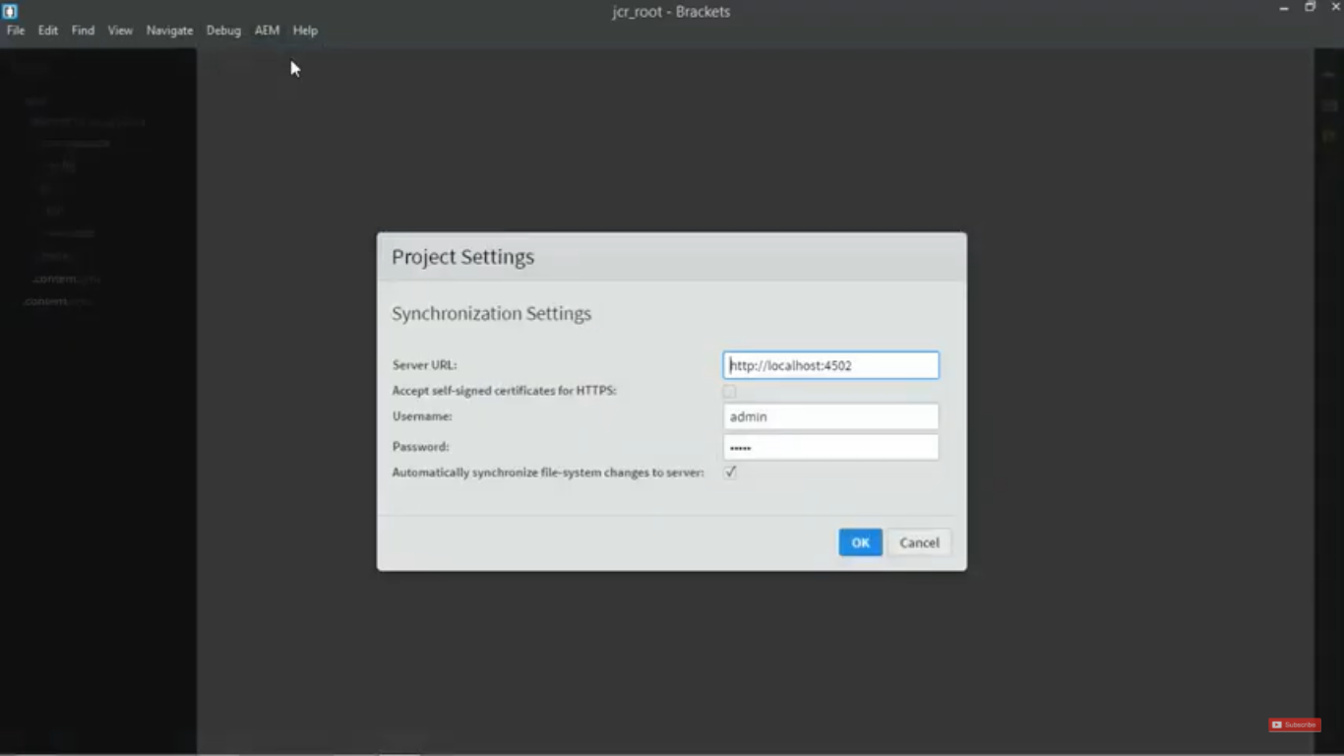

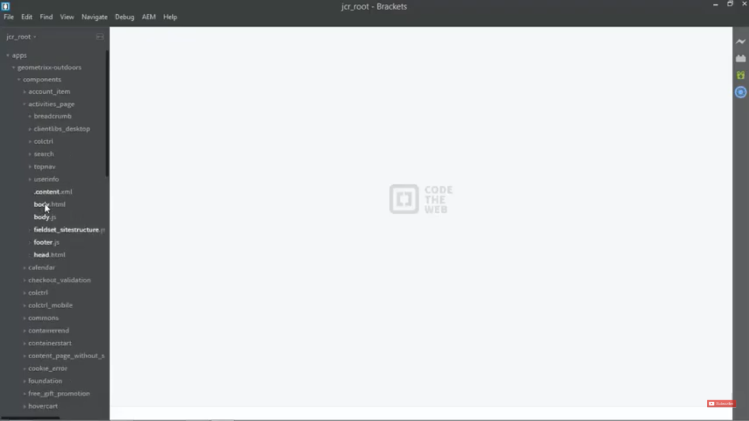

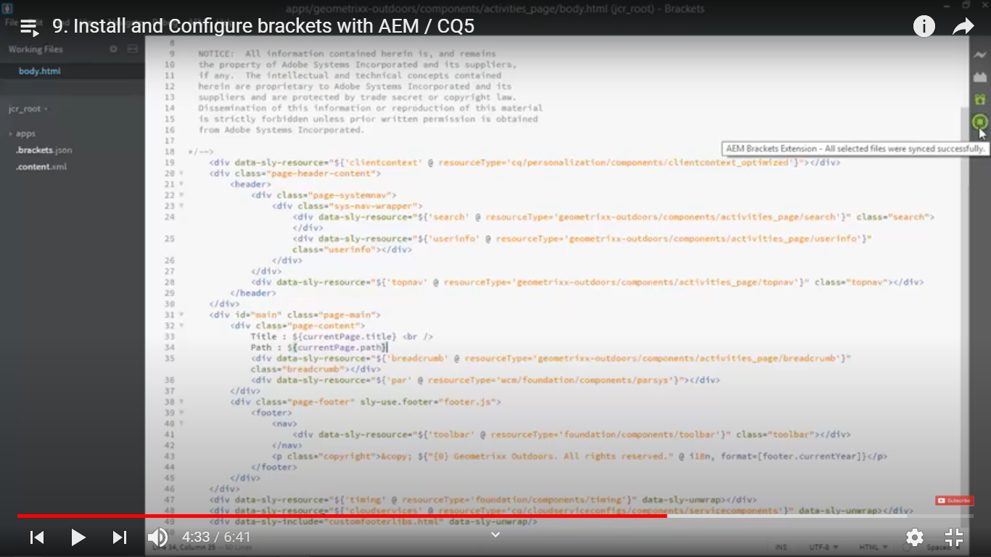

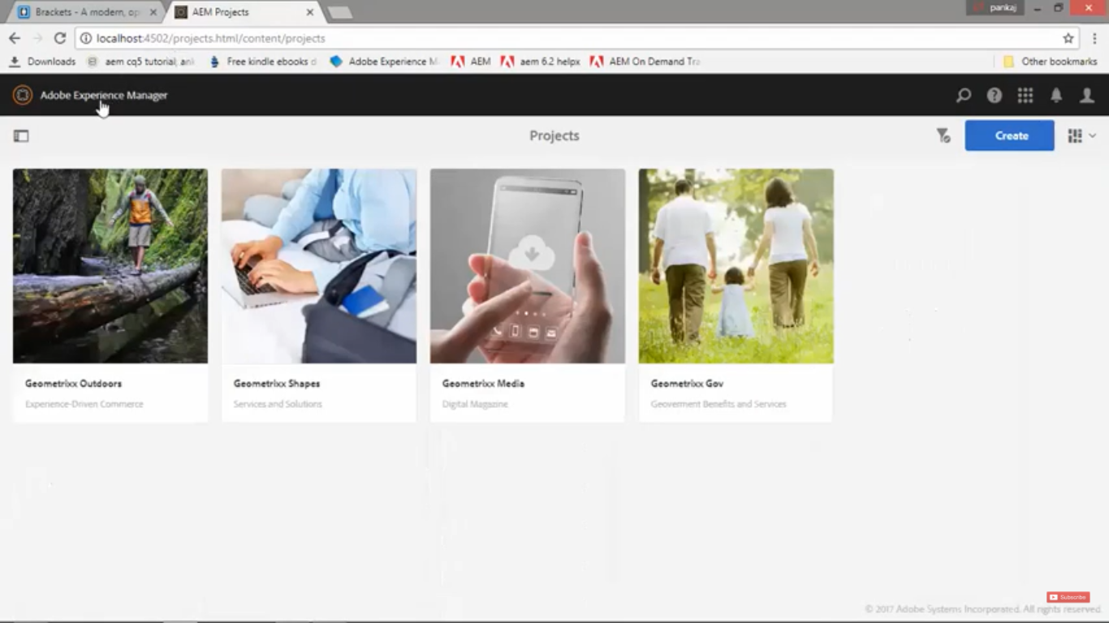

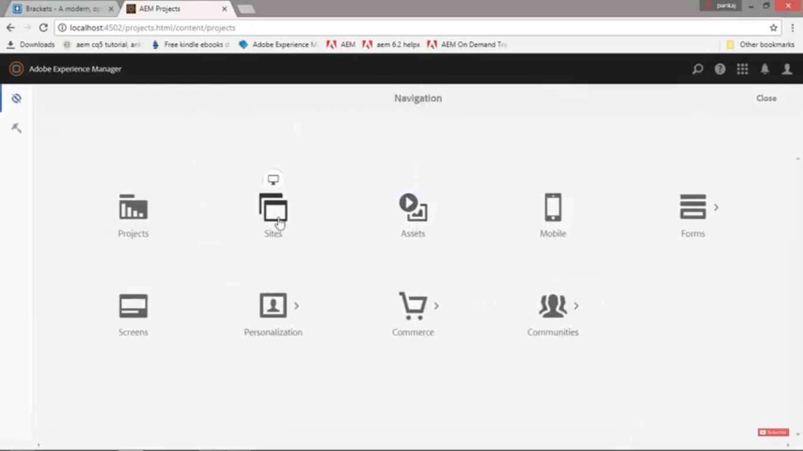

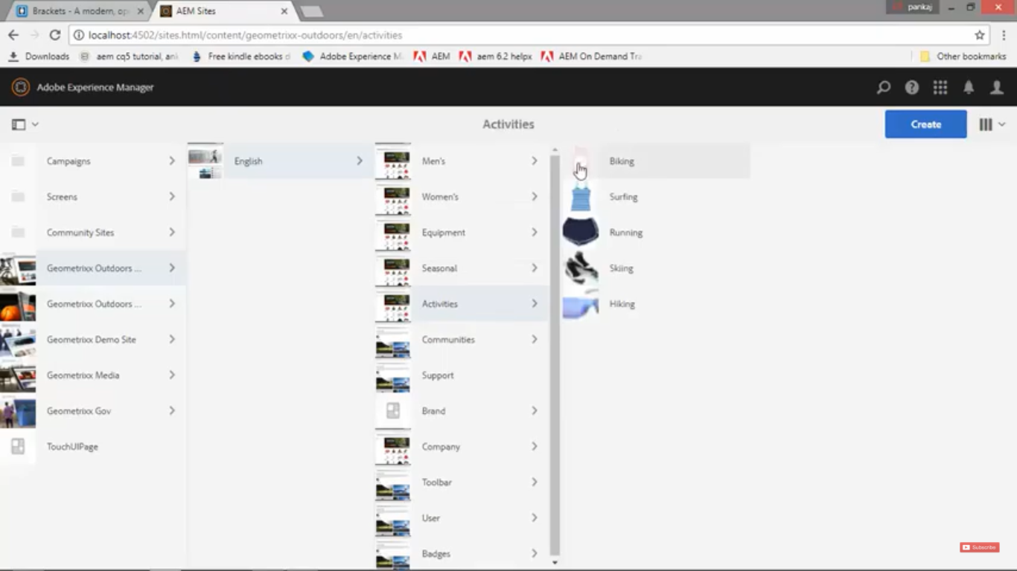

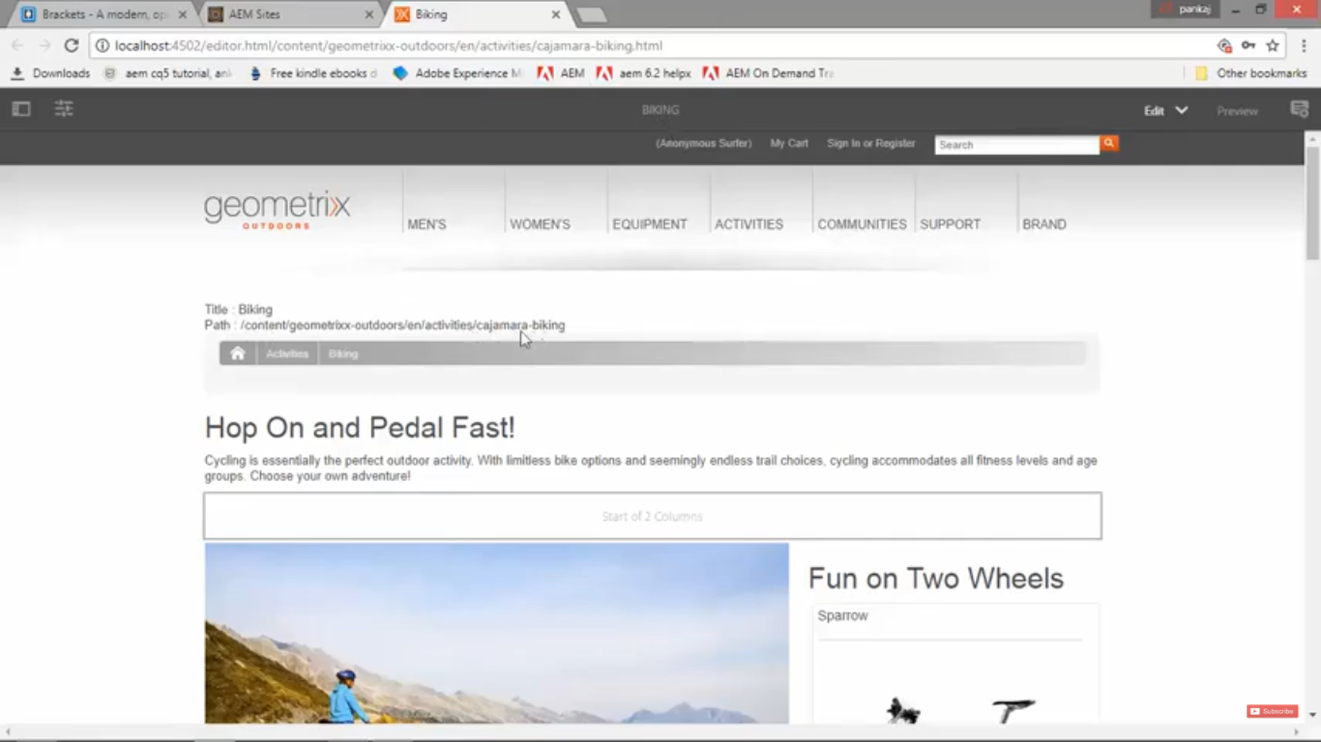

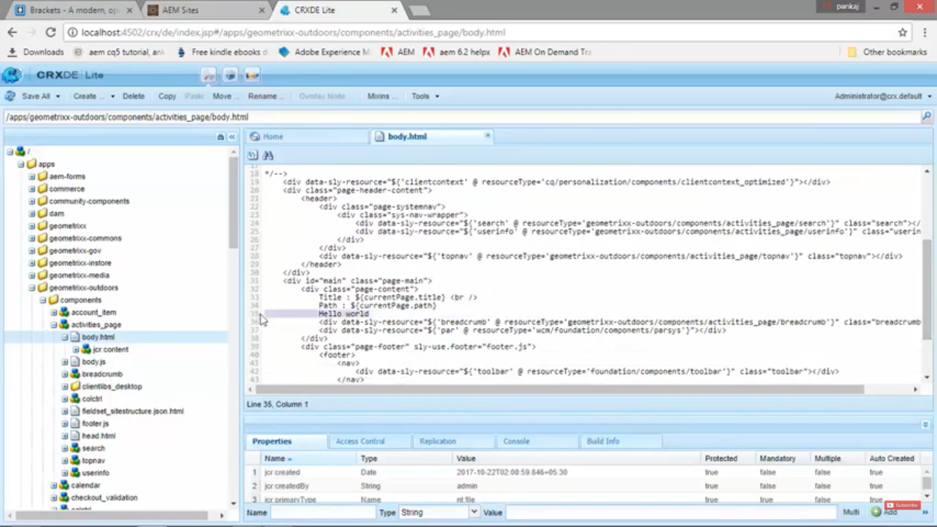

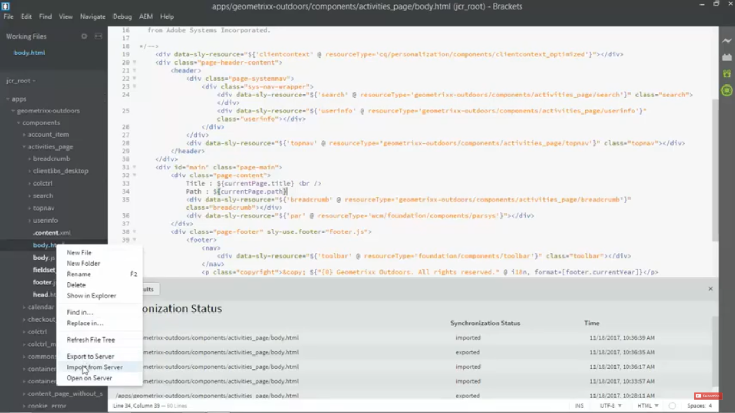

# 10. CRX folder structure or Repository’s Folder Structure :

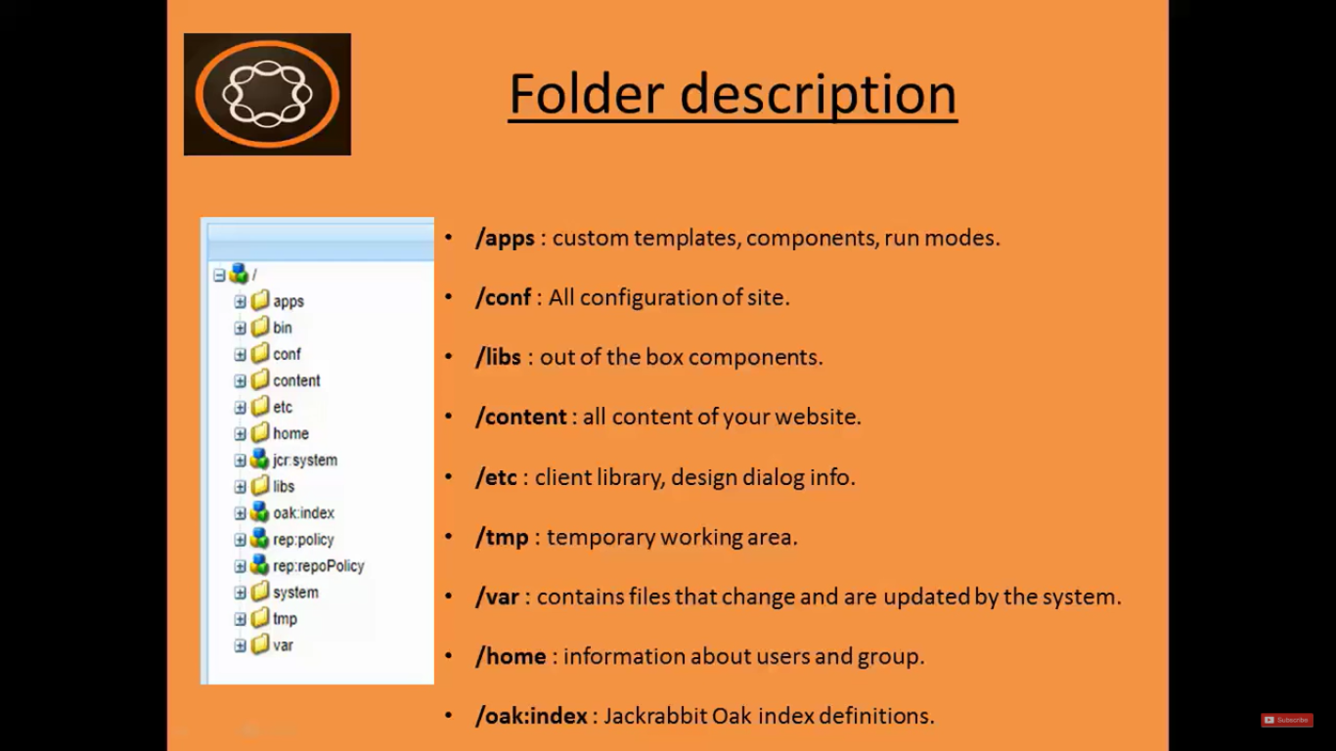

1. **/apps:**

**Custom templates, Custom Components, run modes** details.

When we inherit components, we copy component from **libs** folder to **apps** folder and then we modify that component in **apps** folder.

*Above process* **ensure** that there is **no code loss** *when we upgrade AEM version*.

We just need to *update* **apps** folder *after upgrading AEM to different version*.

1. **/consf:**

All configuration of site. From AEM 6.2 version onwards, it can also store dynamic templates and policies for your website.

1. **/libs:**

Contains the **default components** or **foundation components** which AEM provides out of the box.

Hence, **avoid any modifications** to ***libs*** folder.

1. **/content:**

All content of your website.

When you create a **Page**, then it is created in this **content** folder.

*All the changes* made in the newly created Page will be *available in this folder*.

1. **/etc:**

It contains:

1. Client library --> CSS and JS files
2. Design Dialog info -> which you add from page.
3. **/tmp:**

Temporary working area.

1. **/var:**

Contains files that change and are updated by the system.

These files could be -->

Audit logs

Statistics

Event handlings.

1. **/home:**

Holds Information about users and group.

You can create Users and Roles in AEM.

Also assing roles to users such as Read, Write, Edit, etc.

1. **/oak:index:**

Jackrabbit Oak index definitions.

# 11. Create folder structure in AEM

1. Go to **CRX/DE** --> URL: [http://localhost:4502/**CRX/DE**](http://localhost:4502/crx/de)
2. Create folder named **training** (Give *any name* for your application) under **apps** folder.

**Right Click** on **apps** folder --> Click on **Create** --> Click on **New Folder** --> Name it as **training**

1. **Right Click** on **apps/training** folder --> **Create** --> **New Folder** --> Name it as **components**

**Right Click** on **apps/training** folder --> **Create** --> **New Folder** --> Name it as **templates**

1. **Right Click** on **apps/training/components** folder --> **Create** --> **New Folder** --> **content**

**Right Click** on **apps/training/components** folder --> **Create** --> **New Folder** --> **structure**

1. Click on **Save All** button on top left corner. You’re **Done**. Thank me later. :)

# What is Component? Give examples. What is component Types:

1. Collection of files (HTML, CSS, JSP, Java Servlets, etc)
2. It is a **modular** and **reusable unit** to implement a specific functionality.
3. There are **2 Types** of Components
4. **In-built Components**: *Text* Component, *image/Video* Component, *breadcrumb* Component
5. **Custom Components**: *Header* component, *Footer* Component, *Navigation* Component
6. There are **2 Categories** of Components
7. **Page Rendering Component** (also called ***Parent*** Component)
8. **Child Components** (also called ***Content***Component)

# 12. Create Page Rendering component in AEM:

1. Go to **CRX/DE** ([http://localhost:4502/**CRX/DE**](http://localhost:4502/crx/de))
2. Go to your **project** or **application** which is present under **apps** folder and follow below path:

Path: apps/training/components/structure

1. **Right Click** on **structure** folder --> **Create Component** --> details --> **Next** button --> **OK** button.

|  |  |  |
| --- | --- | --- |
| **Field** | **Value** |  |
| Label | Contentpage |
| Title | We.Train Contentpage component |
| Description | This is my page rendering component |
| Super Type | wcm/foundataion/components/page |

1. You can see newly created **contentpage** component on left side in **Explorer Pane**.
2. You can see newly created **component’s** **properties** in **properties pane** at the bottom of the page.
3. Click on **Save All** button on top of the **CRX/DE** page.
4. You can find **Super Type** **component** in **libs** folder in **CRX/DE** at below path:

**Path:** /libs/wcm/foundation/components/page

1. *While creating page rendering component* you need to inherit from this **Super Type** **component**.
2. Rename /apps/training/components/structure/contentpage/contentpage.jsp to **contentpage.html**.
3. Open the file **contentpage.html** and remove all the default contents of the file.

Because we want to create our site in **slightly** and **not** in **JSP**.

**Sightly** is **Hypertext Template Language** (**HTL**) specifically designed for AEM.

1. Copy contents from **contentpage.html** file from below path to newly created **contentpage.html** in your AEM project [AEM](https://github.com/pankajchhatri/AEM) --> [Developer course](https://github.com/pankajchhatri/AEM/tree/master/Developer%20course) --> [Chapter 5 Introduction to Content Rendering](https://github.com/pankajchhatri/AEM/tree/master/Developer%20course/Chapter%205%20Introduction%20to%20Content%20Rendering) --> [Lab Acitivity - II](https://github.com/pankajchhatri/AEM/tree/master/Developer%20course/Chapter%205%20Introduction%20to%20Content%20Rendering/Lab%20Acitivity%20-%20II) --> [Task - Create a Page-rendering Component](https://github.com/pankajchhatri/AEM/tree/master/Developer%20course/Chapter%205%20Introduction%20to%20Content%20Rendering/Lab%20Acitivity%20-%20II/Task%20-%20Create%20a%20Page-rendering%20Component) --> [contentpage.html](https://github.com/pankajchhatri/AEM/blob/master/Developer%20course/Chapter%205%20Introduction%20to%20Content%20Rendering/Lab%20Acitivity%20-%20II/Task%20-%20Create%20a%20Page-rendering%20Component/contentpage.html)

# 13. Create Template and then create Page using the same Template in AEM:

**What is Template?**

1. Itis a **Blueprint** or **Layout**. It has *same hierarchy as page* but with **no content**.
2. *Just like* there is **ClassInit** in **JAVA**, *similarly* we have T**emplate** in AEM.
3. It provide ***consistent page structure*** throughout the project.
4. In AEM we ***need template to create a page***.
5. **Template** is ***associated with*** **Page Rendering Component**.
6. We use property called **sling:resourceType** where we provide the **path** to our **Page Rendering Component**.

**What is Template?**

1. Open **AEM instance**. Go to **CRX/DE** --> URL: [http://localhost:4502/**CRX/DE**](http://localhost:4502/crx/de) console.
2. **Right Click** on node /apps/training/templates
3. Select **Create Template** option. Enter below details:

|  |  |
| --- | --- |
| **Field** | **Value** |
| Label | contentpage |
| Title | We.Train Contentpage component |
| Description | This is contentpage template for this training |
| Resource Type | training/components/structure/contentpage |
| Ranking | 1 |

1. Set **Ranking** field = 1 to order in which this newly created template *appears in dialog* when we create a page.
2. Click on **Next** button. Give below value

|  |  |  |
| --- | --- | --- |
| **Field** | **Value** | **Meaning** |
| Allowed Path | /content(/.)? | Template will be available for creating page in any website |

1. This is the **path** *where this newly created template can be used* (i.e. ***all places***).
2. Click **Next** button 2 times without entering values for next 2 fields.

|  |  |
| --- | --- |
| **Field** | **Value** |
| Allowed Parents |  |
| Allowed Children |  |

1. Click on **Save All** button.
2. Click on node **training/templates/contentpage**. See the **Properties Pane**. You will see **allowedPaths** field set to value **/content(/.)?**
3. **Expand** node **training/templates/contentpage**. You will see a **child node** named **jcr:content**.
4. See the **Properties Pane** of this child node **jcr:content**.
5. See property **sling:resourceType** with value **training/components/structure/contentpage**
6. Property **sling:resourceType** points to ***path of Page Rendering Component*** which is **contentpage** in our case and mentioned URL in step 9.

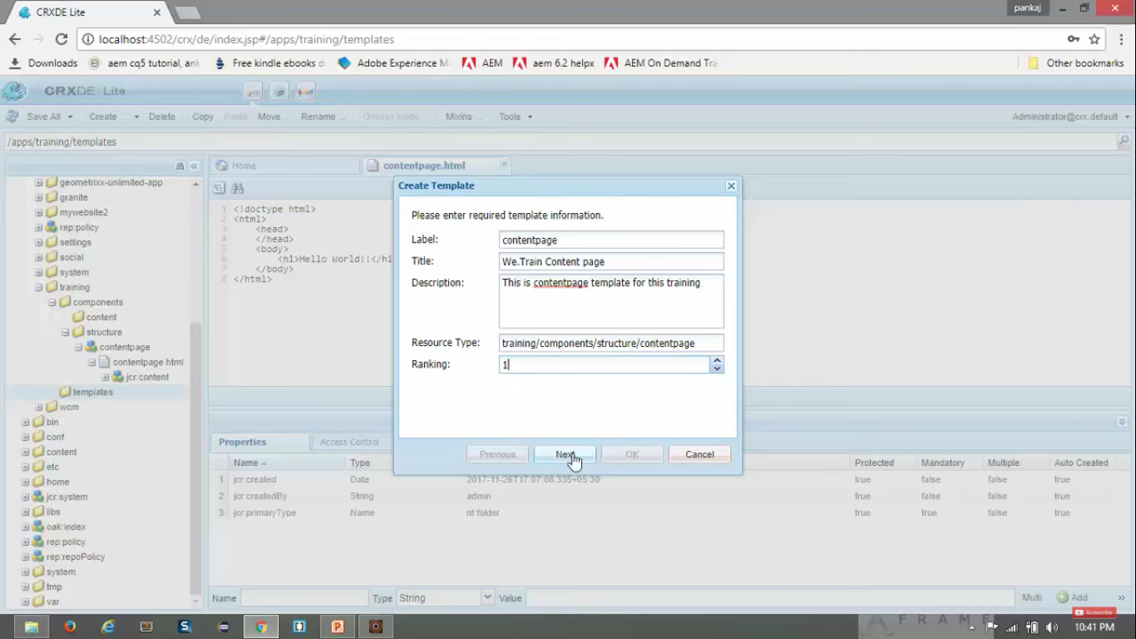

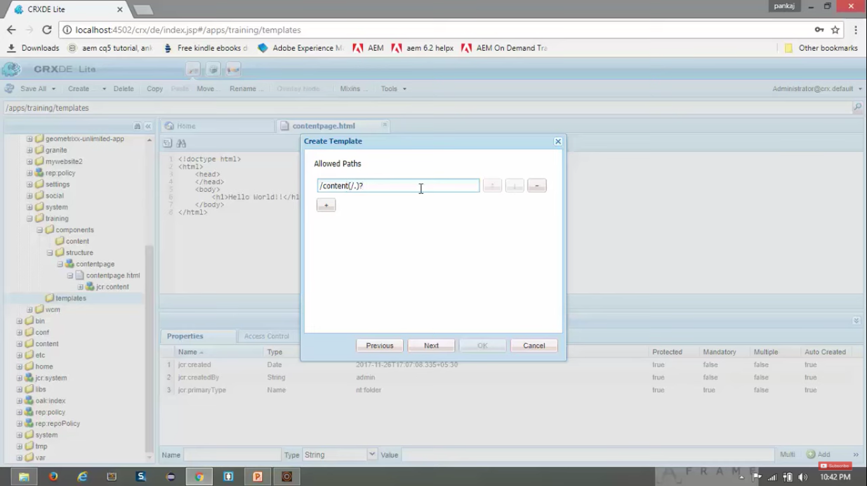

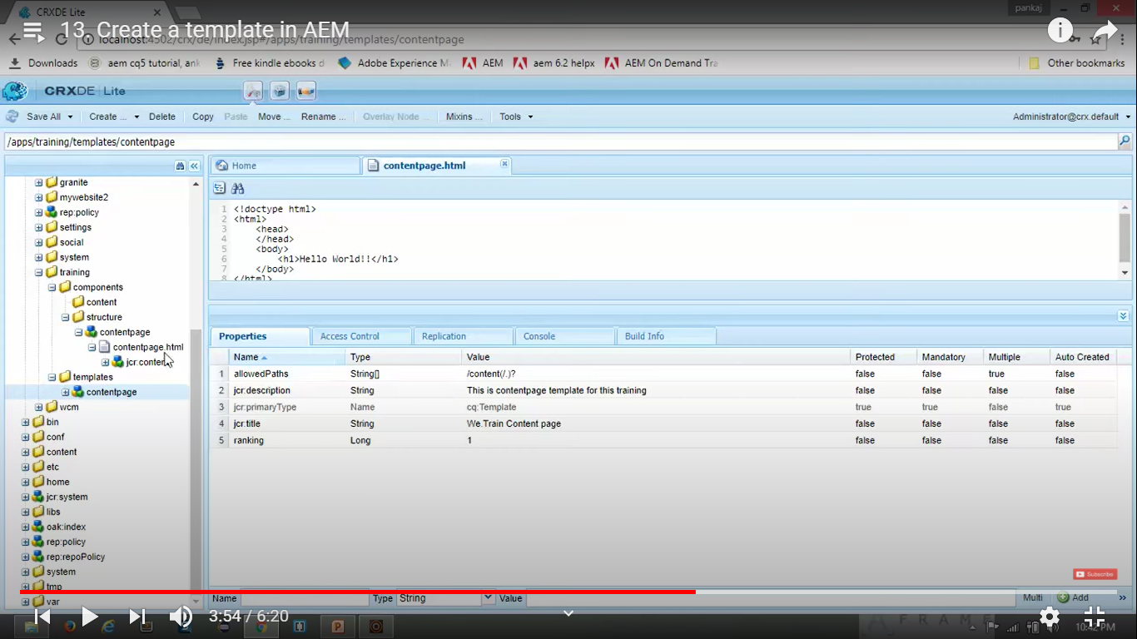

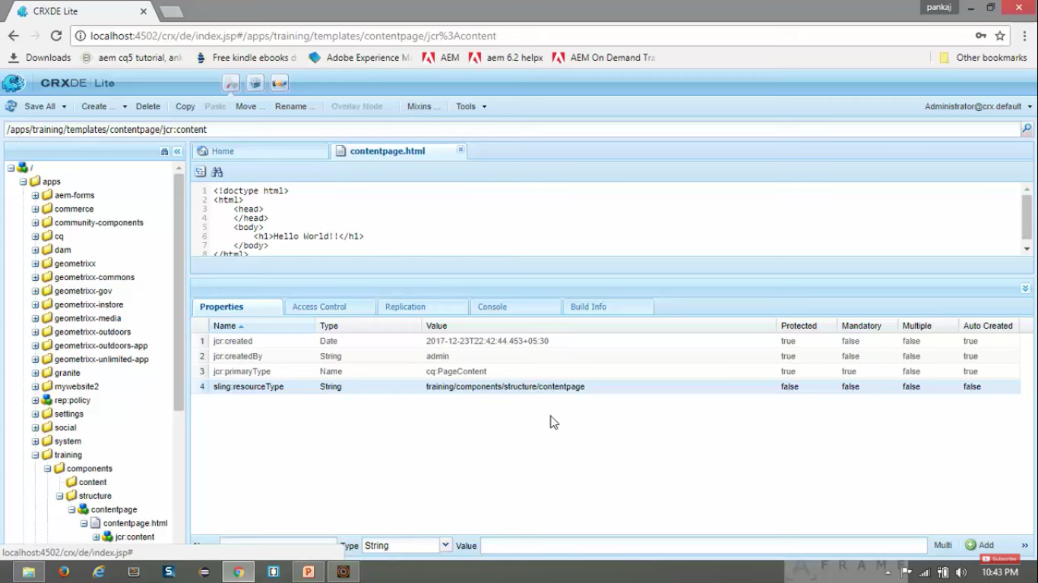

1. Now we have created **Template**. It’s time to create **Page** *using this newly created Template*.
2. Go to **Sites Console**. URL: <http://localhost:4502/sites.html/content>
3. Click on **Crate** button. Select **Page** option.
4. You can see *newly created page* with **Title** “*We.Train Content page*”.
5. **Select** this *newly created page* --> Click on **Next** button. Enter below *values*. Click on **Create** button.

|  |  |
| --- | --- |
| **Field** | **Value** |
| Name | we-train |
| Title | We.Train |

1. Click on **Create** button.
2. You can see you *Page has been* *created* on the same page. <http://localhost:4502/sites.html/content>
3. **Click** on that *newly created Page* having **Title** “*We.Train*” *to select this Page*.
4. **Click** on **Edit** button on Top of the page.
5. This will **open** your *newly created Page* in **editing mode** at <http://localhost:4502/editor.html/content/we-train.html>
6. It should display “Hello World” on the Page. If your page is *blank*, check whether **sling:resourceType** property of node **/apps/training/components/structure/contentpage** is having correct value of **taining/component/structure/contentpage**. That means it should point to **Page Rendering Component**
7. **Done**. We have **created a** **Template** and then **created a Page** using the **Template**. Thank me later :)

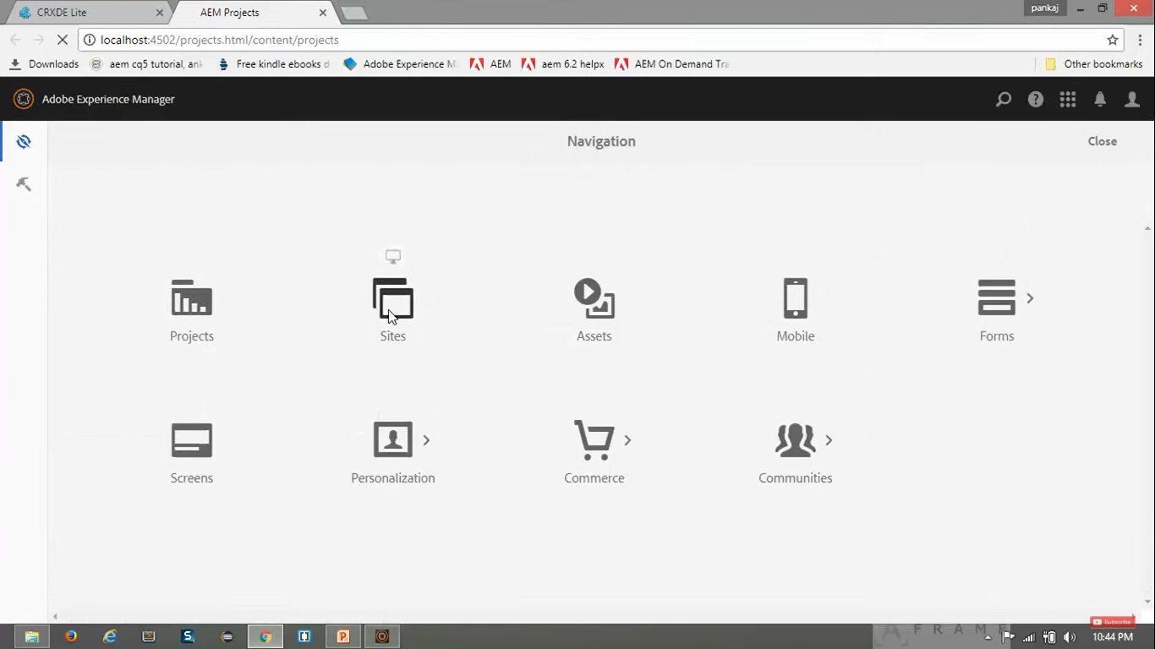

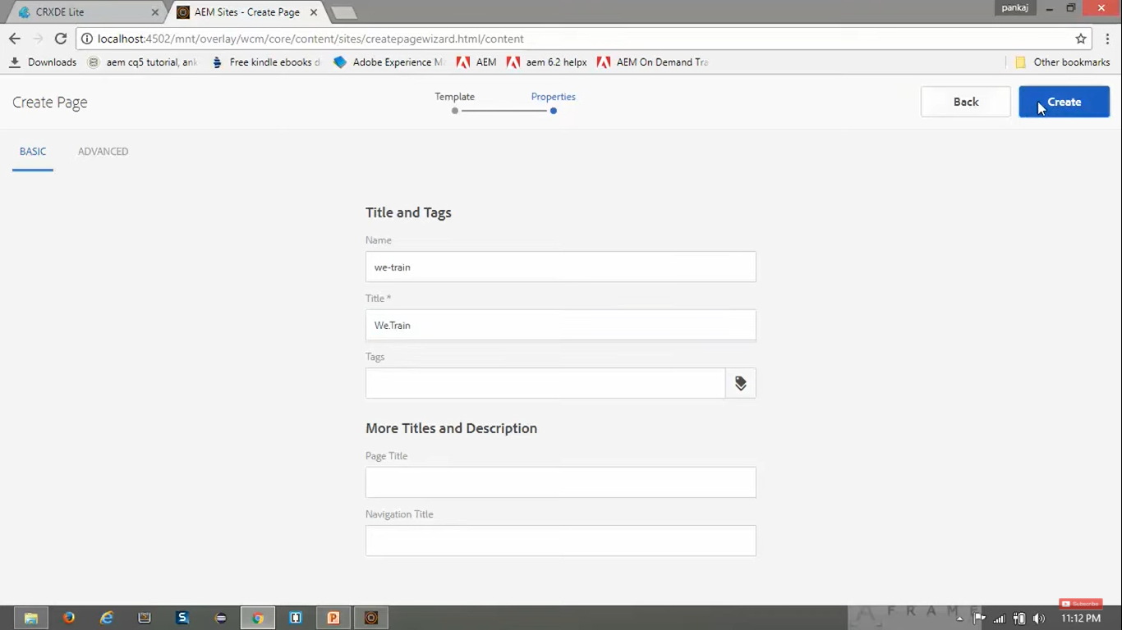

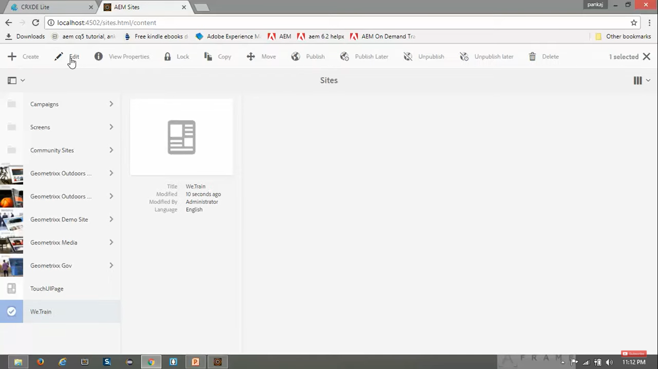

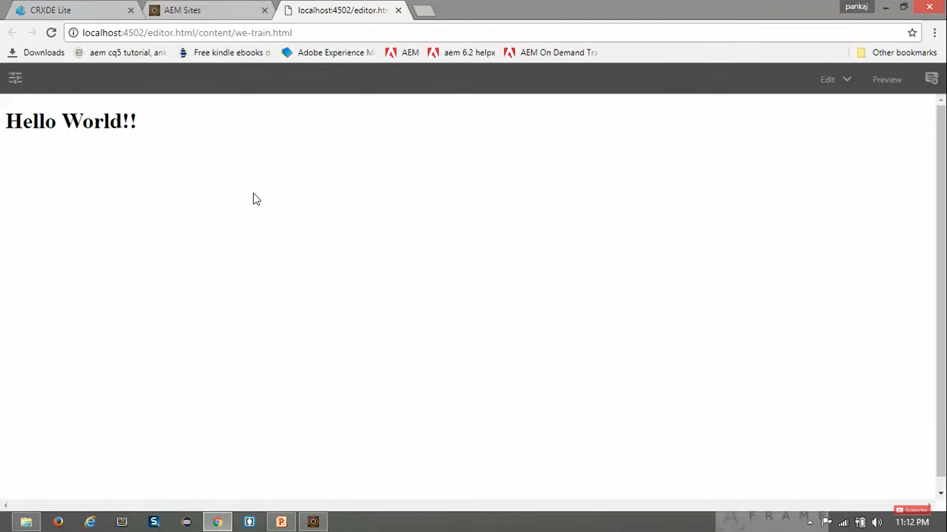

# 14. Decomposing a URL in AEM:

1. Open URL: <http://localhost:4502/editor.html/content/we-train.html>
2. We see **editor.html** in URL because we are currently logged on to **Authoring environment**.
3. Now **remove** thetext **editor.html** from this URL to make URL as below:

[http://localhost:4502/ content/we-train.html](http://localhost:4502/%20content/we-train.html)

1. When we create a page, what happens behind the scenes? Let’s check that.
2. Open **CRX/DE** URL: [http://localhost:4502/**CRX/DE**/](http://localhost:4502/CRX/DE/)
3. Go to /apps/trainings/templates/contentpage/**jcr:content**
4. We have set value of **sling:resourceType** property to **Page Rendering Component** ie. **training/component/structure/contentpage**
5. When you created a page, a node named “we-train” got created in **/apps/content** folder. Where **we-train** is the *label* we assigned to our *newly created page*.
6. See below image to understand decomposing of the URL in AEM

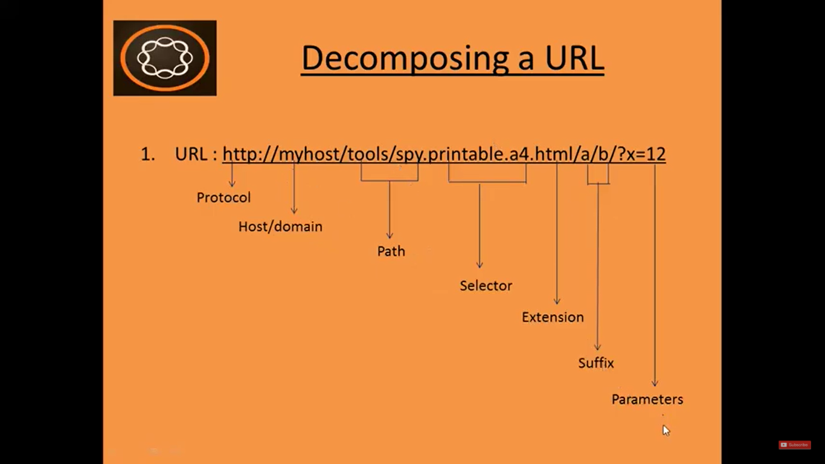

So if we have URL: <http://myhost/tools/spy.html>

This URL contains protocol (http), domain name (myhost), path (tools/spy) and extension (HTML).

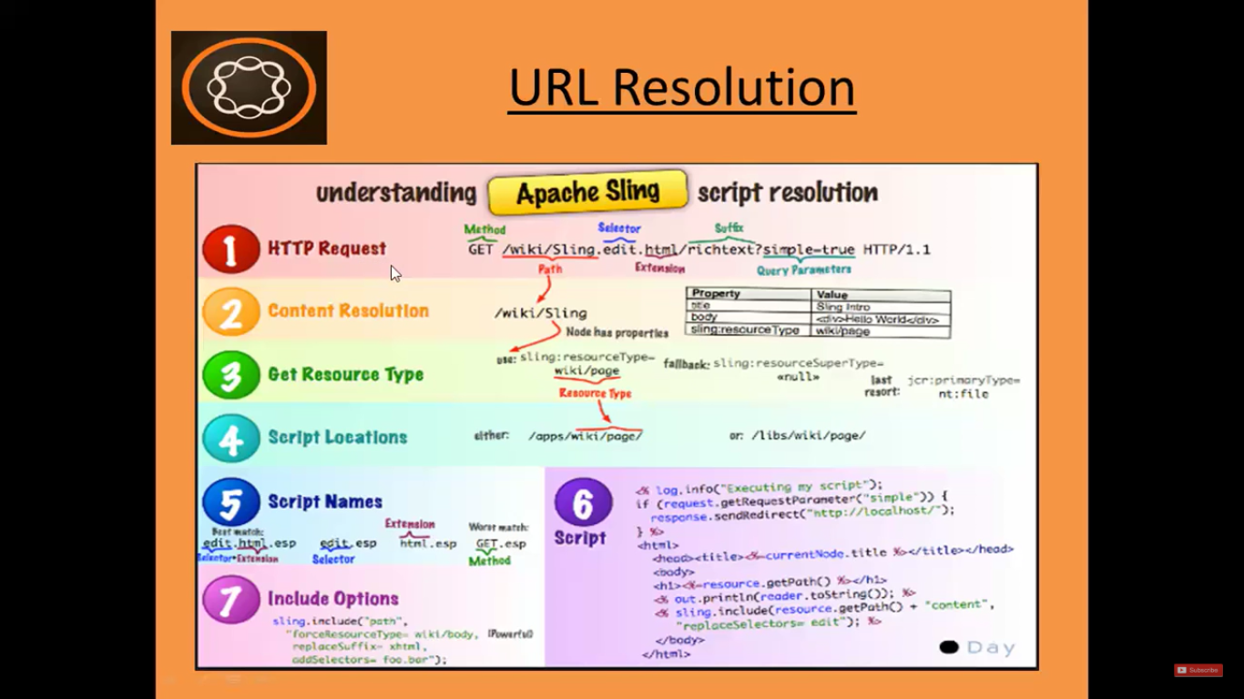

# 15. Apache sling script resolution:

1. Let say we have entered URL: <http://localhost:4502/content/we-train.html>
2. Here it will check for node /**content/we-train**.
3. Next, it will check **sling:resourceType** property of its child node **jcr:content** of this node i.e. “**/content/we-train”**.

|  |  |
| --- | --- |
| **Field** | **Value** |
| sling:resourceType | training/components/structure/contentpage |

1. Go to path mentioned in **sling:resourceType** property. **training/components/structure/contentpage**
2. In that, you will see a *child node* named: **contentpage.html**.
3. That is the resource will be served to browser.
4. This is how apache resolved resource of the entered URL.

